A mobile application for young adults with dyslexia and those who struggle with English (I.E. those who are ESL):

Programming Project: OCR A-level

The report for the project.

Megan Cooper

H446-03

Contents:

Overview: 3

Introduction: 3

Overall Approach: 3

Phases One: 3

Analysis: 3

What is the project? 3

Justification: 3

Research 3

Phasing: 4

Stakeholders: 5

Features: 6

Limitations: 9

Requirements: 9

Success Criteria: 9

Algorithms: 11

Design: 14

Screen Designs 14

Test Plan: 15

Implementation: 17

Colour Changer Screen: 17

Simple Text Editor: 20

PDF Viewer: 24

Text to Speech (TTS): 28

Testing: 31

Phases Two: 34

Analysis: 34

Success Criteria 34

Algorithms: 34

Design: 39

Screen designs: 39

Class Diagram: 40

Detailed Class Breakdown: 60

Test Plan: 61

Implementation: 62

The Quiz: 62

Testing: 69

Code Review: 70

Phase Three: 70

Analysis: 70

Implementation (Pseudocode ONLY): 70

Opening Files : 70

File Directory: 71

Saving text files: 71

TTS: Pitch: 71

Score sheets: 71

Home page (ESL & Dyslexia): 71

Evaluation: 72

Table One: Screenshots 73

Table Two: Videos; 75

# Overview:

## Introduction:

I have chosen to complete this project by creating an application that will aid/ help predominantly young adults (ages 11+) that struggle with their reading. It will run on android operating systems (OS) on mobile phones.

## Overall Approach:

To complete this project, I will be using android studios and after consideration of device I want this program to run on, I have decided to use Application programming interface (API) 14 4.0 (Ice-cream sandwich) as this will allow my application to run on approximately one hundred percent of Android phones, therefore, it will be widely accessible for all. I will be using an iterative waterfall methodology to develop this application as it allows for the sequential development starting with design through to evaluation, but I’ll be able to return to previous stages i.e. if the stakeholders disagree with the design of a feature after its been coded and tested, then I’ll be able to return to the development phase without it causing delays later.

# Phases One:

## Analysis:

### What is the project?

This project is an educational application that is designed to help those who struggle with their reading with a clear focus that it is for those whom struggle with dyslexia, however it is not explicit for those therefore making it an application available for many who struggle but are of a young adult in age and above. I’ve chosen this as my project as “It's estimated up to 1 in every 10 people in the UK has some degree of dyslexia” – the NHS website. It will be a mobile application as today it is incredibly uncommon for young people to be without access to a mobile, therefore it is something that is easily accessible.

### Justification:

#### Alternatives:

Below is a list of alternatives that are currently available for those who require help with their reading, however they have the following drawbacks:

#### Paper textbooks and printed reading material:

* Reading books available are limited,
* Books designed for those with dyslexia often have a “reading age” which can often leave the readers feeling dim-witted.
* Furthermore, the reading age for specially designed reading books is limited to approx. 8+ even when advertising the use for teenagers.
* The paper text books that are available for those who struggle are often very child-like and they use bright colours and simple cartoons etc. to explain the point (again makes those who struggle feel dim-witted).

#### Mobile Applications:

* The mobile applications are often based around games to work on making connections and therefore are not always helpful, furthermore the ‘games’ can be rather child-like therefore, similarly to that of the paper textbooks they can feel juvenile and patronising.

#### *Research* and Existing Features:

* Below are a few examples of applications that are currently available (These are what comes up when searching for applications under the search terms ‘Dyslexia apps’, ‘dyslexia apps for adults’ and ‘Dyslexia apps for teens’:

1. Dyslexia eye games which is designed by PMQ software; this is described as an eye game that helps “improve visual perception”, which is something that many with dyslexia and other reading impairments. However, after having a look at the application myself and further showing it to my stakeholders, I’ve found that it requires in-application purchases to be able to complete all the games and that it uses very primary colours and repetitive tasks throughout making it feel very childish. Furthermore, it has a PEGI 3 rating on Google play and within the application is split into age categories, 3-4, 4-5, 5-6 and 6+ which can make my target audience of young adults/ teens feel uncomfortable and dim-witted as they are then labelled as needing work from that of lower ages.
2. HexaDyslexia which is designed by the learning works team Schrodinger; this is a notetaking platform therefore, while it has a simple layout, users are only able to choose between two different background colours (black/while). Users are also able to choose between four different fonts (Regular, Dyslexie [Default], Dyslexie Bold and Open Dyslexic), after talking to my stakeholders they agreed that the Open Dyslexic and Dyslexie Bold were difficult to read furthermore, the letters were displayed in different colours however the colours weren’t always clear on the background. Finally, both me and my stakeholders found that the application made the keyboard lag making typing very difficult as it would often miss letters and other keys such as spaces and punctuation. Which they sometimes found difficult to recognise as they found it hard to connect which letters were missing from which words.
3. Ultimate phonics reading application which is designed by Spencer Learning; this is an application that provides lessons on phonics and while it does help with improvement of using phonics to sound out words, the lessons are long and plain therefore young adults don’t want to sit and listen to the lessons. This application isn’t interactive so there is very little for the users to do. Furthermore, to access all the lesson it includes there is an in-application purchase.

Overall, all these applications have both benefits and drawbacks however, the common pattern that I have found is that all the available applications can be very childish in nature or they had patronising tasks, making the older students feel undervalued with in their education. Furthermore, applications such as Ultimate phonics reading application which independently work well but there isn’t anything available that combines features to help with all aspects of dyslexia/ reading difficulties.

#### Computational Suitability:

This project clearly has computational suitability as it will require inputs, outputs and processes.

##### Inputs:

* Keyboard inputs,
* Touch from the User input,
* Files for the PDF reader,
* Inputs for the text editor.

##### **Outputs**:

* The background colour (as chosen by the user),
* Display of current activity in use,
* Use of a side bar & icons.

##### **Processes**:

* Evaluating the change of state from one activity to another.

##### **Storage**:

* Content data e.g. the PDF files, text docs etc.
* Temporary storage of the screen colour that the user has chosen,

#### Computational Complexity:

This is solvable with computational approaches as it will be an educational application for young adults that struggle with dyslexia, therefore it needs to be done with a computer as I wish for it to be accessible no matter where the user is. It would also use computational methods as it will need to be able to change its outputs such as the background colour based upon the users selected colour as everyone who suffers dyslexia finds having different coloured backgrounds easy to read from. I am also that they can change the background colour, therefore, it needs to be able to process data given and then be able to output any changes made. The inputs and outputs. I believe this is a complex enough to use computational methods as it will need to work on multiple platform, but I will not to have to code it more than once.

### Phasing:

To keep this project organised it will be broken in to different phases which will consist of manageable sub-problems. Each phase will be broken into stages; Analysis, design, implementation, testing and evaluation. Currently, I am planning for a minimum of three phases. Throughout, this project I will also be contacting my stakeholders at the end of phase two and three thus I will be able to decide if I will need any additional phases. My phases will currently be broken up as following:

#### Phase One: Components:

For phase one I am going to make all the components that are going to be required but as individual prototypes excluding the comprehension checker before placing them all together to create the finish application in phase three. The following is a list of components the application requires:

* Default off white background,
* The option to swap the colour of the background,
* A PDF viewer,
* Word pronunciation (Google TTS),
* Synonyms
* Text editor

#### Phase Two: Components:

For phase two I will be focusing on the comprehension checker which after much consideration I have decided to compete as a quiz-based application this is because comparison of the English Language is increasingly difficult and time consuming so isn’t suitable for this project at this stage.

#### Phase Three: Components:

For phase three I will be combining all of the components from phase one and two making sure that they work when within the same android studio file therefore creating a full application rather than a several little apps. I will also be making the application more user friendly such as a side bar for navigation and other features such as a page that explains the different features. Furthermore, I will be cleaning up any redundant code and removing features that my stakeholders decided they may not like if required. Dependent upon stakeholder views of the final application after stage three I may add further stages.

### Stakeholders:

This system is intended for general purpose, designed especially for education use, so the stakeholders for this project could be wide range of people. Below is a list of those who will be my stakeholders.

#### Stakeholder One:

I can use a name for stake holder one opposed to stake holder two as Frances is my younger sister and thus I have parental permission to use her name within the project write up.

|  |  |  |  |
| --- | --- | --- | --- |
| Name: | Frances | Age: | 15 |
| Job Role: | Full time student at a UK high school Y11 | | |
| Expected usage of the project. | Frances is a Y11 student, studying for her GCSE’s, however she has struggled with dyslexia since she was little, she will hopefully find this useful and portable as she often finds using the material provided daunting or childlike. | | |
| Why is this solution appropriate? | Frances constantly has her mobile phone meaning that she will be able to access this where ever she goes which this system allows for. She also finds that the current options for help are quite often separated whereas with this application everything will be in one | | |

#### Stakeholder Two:

For the next, stakeholder I will be using a small group of approximately 9 /10 students from a local high school whose age ranges vary from 11 – 14 (Y7 to Y9), because of this I have selected, three people to focus on but I will be feedback from the whole group. Due to safeguarding issues I am not able to provide names of the students or the school that they attend gaining, so I will refer to the two students as M and F.

|  |  |  |  |
| --- | --- | --- | --- |
| Name: | Mrs R Bird | Age: | N/A |
| Job Role: | Librarian at local high school (also runs English intervention) | | |
| Expected usage of the project. | Mrs Bird, while not a typical user will be helping with some relay to the students as they feel more comfortable talking with her than me in the earlier stages of communication with the students and further helping me with the beginning of deciding what may be useful for the students. However, I will also be having Mrs Bird test the project so that I can ensure that the project is user friendly for all, I feel that by having an adult who excels at English it would be beneficial as she will be able to help correct where I may have got words/ definitions incorrect etc. | | |
| Why is this solution appropriate? | N/A | | |

|  |  |  |  |
| --- | --- | --- | --- |
| Name: | M | Age: | 13 |
| Job Role: | Male student at local high school | | |
| Expected usage of the project. | M is a Y9 student who struggles with reading as they find spaces in the book are too close together meaning that they lose their place in the book/ on the page, however, M doesn’t have a dyslexia diagnosis and doesn’t struggle with other aspects associated with dyslexia so some of the features may not be used. | | |
| Why is this solution appropriate? | Similarly, to stakeholder 1 M has consent access to their mobile phones, furthermore M struggles with paper-based solutions that are available. | | |

|  |  |  |  |
| --- | --- | --- | --- |
| Name: | F | Age: | 11 |
| Job Role: | Female student at local high school | | |
| Expected usage of the project. | F is a Y7 student, who similarly to stakeholder 1 this student struggle with dyslexia however unlike stakeholder 1 they have used multiple other systems but struggles with many, all for different reasons, although most commonly the background colour and it isn’t always changeable. | | |
| Why is this solution appropriate? | Similarly, to stakeholder M, F has consent access to their mobile phone, furthermore F dislikes having paper written notes to write and carry around with them. | | |

#### Stakeholder Three:

For this stakeholder I have found a small group of people all of whom English is their second language, they’re ages range from 15 to 35. They requested that their names remained out of the report but were happy to provide feedback. The groups quality of English varies, some can understand English when they hear it but not when they see it so features such as the text to Speech. Others however struggle with the homophones as they don’t understand the difference between meaning.

|  |  |  |  |
| --- | --- | --- | --- |
| Name: | I | Age: | 15 |
| Job Role: | A male student preparing for GCSE exams | | |
| Expected usage of the project. | I is a Y11 student, who has English as a second language, while they can understand English when it is spoken to them they struggle when the words are written in front of them so will find the text to speech (TTS) a helpful feature, furthermore this stakeholder feels that by having the TTS and notepad and quiz (and other features) together will be beneficial as they aren’t required to swap when using them in a quick situation. | | |
| Why is this solution appropriate? | This solution would be appropriate as the user is likely to have access to their mobile, furthermore, as the application will not require an internet connection the use of features such as the TTS means that they will be able to use this at all times. For example, if the user was waiting for a bus they would be able to listen to the way the phase is spoken so that they were more confident before ordering their ticket for the journey. | | |

|  |  |  |  |
| --- | --- | --- | --- |
| Name: | II | Age: | 27 |
| Job Role: | A female recent immigrant to the UK | | |
| Expected usage of the project. | II struggles with the English language as she has just made the move from Portugal to the UK. As a result, for the time being I would only expect this typification of a user to find the quiz handy as it help solidify words that are often difficult to learn and understand. | | |
| Why is this solution appropriate? | This solution would be appropriate as the user is likely to have access to their mobile, furthermore, as the application will not require an internet connection the use of features such as the quiz will be accessible no matter where the user is. | | |

|  |  |  |  |
| --- | --- | --- | --- |
| Name: | III | Age: | 34 |
| Job Role: | A male University student (History as subject) | | |
| Expected usage of the project. | III understands the English language but with upcoming university exams wants to make sure that he is confident with the homophones furthermore, as this user is a student of an essay-based subject they will also be likely to use the word editor to organise his notes and assessments. | | |
| Why is this solution appropriate? | This solution would be appropriate as the user is likely to have access to their mobile and wants a place to keep all of his notes safe as he prefers to type they. Furthermore, this user is wanting to make sure that he understands the simple words of English thus not jeopardising misunderstanding an exam question as this could result in him losing marks which may gain him the marks required to achieve a higher grade. | | |

### Features:

Below is a list of features that my application with have some of which are essential, and others are features I am wishing to place within the application either for user comfort or ease. I have also had an initial meeting with the teacher of this group to see what features the students may feel they require furthermore; Mrs Bird also spoke to the special educational needs coordinators (SENCO) and teachers whom often work with many students who struggle with their literacy.

#### Notes from the meeting with Mrs Bird:

As part of my project I have choose to use one of the local high schools, as a stakeholder however because my application is designed for very specific people (those who struggle with English) I am focusing on a small group of students of which the Librarian (Teacher) holds smaller classes with students ages 11 - 14. Consequently, I have chosen to work with the Teacher and their classes to get ideas and implement/test my project as I felt that this set of students would benefit the most from this programme and I would benefit from their inputs in to the design as they are my target audience. However, for the first few meeting they will be primarily with just the teacher so not to place added pressure in the students making them feel uncomfortable.

When I first meet with the Teacher it was only a short meeting whereby I let her know what it was that I was wishing to do and how she could help. We had a few ideas, but the Teacher said she would e-mail me with some ideas after having more time to think what may be helpful and gain a few ideas from the students that they are currently helping. I have also agreed to have a more in-depth meeting on the 5th of April. Below are screenshots of the e-mail exchanges that we have had, I will also include a screenshot of the initial ideas that the Teacher has provided me with and I will proceed to evaluate how do able those ideas are. 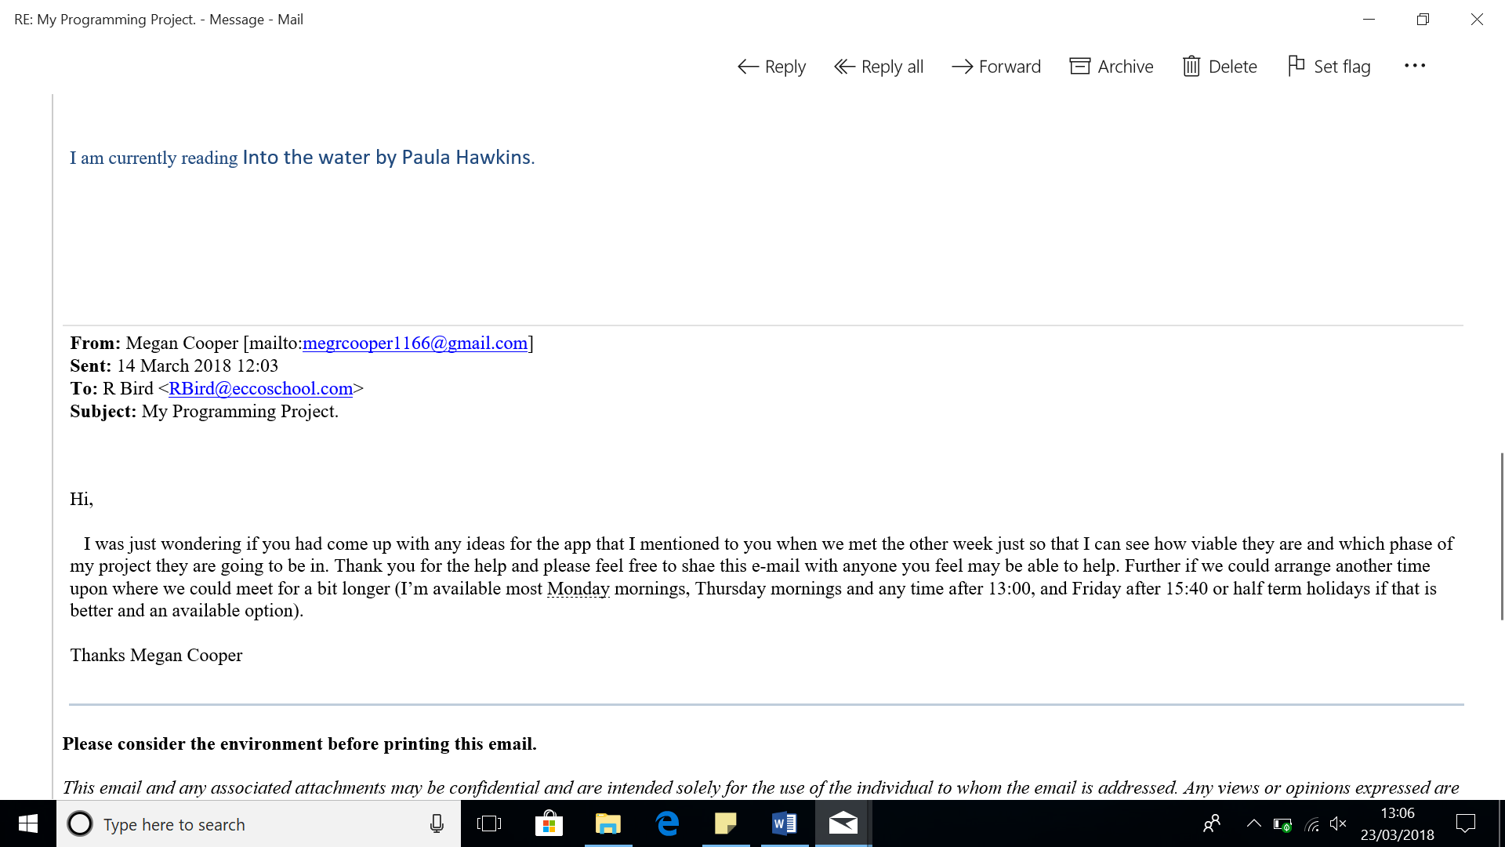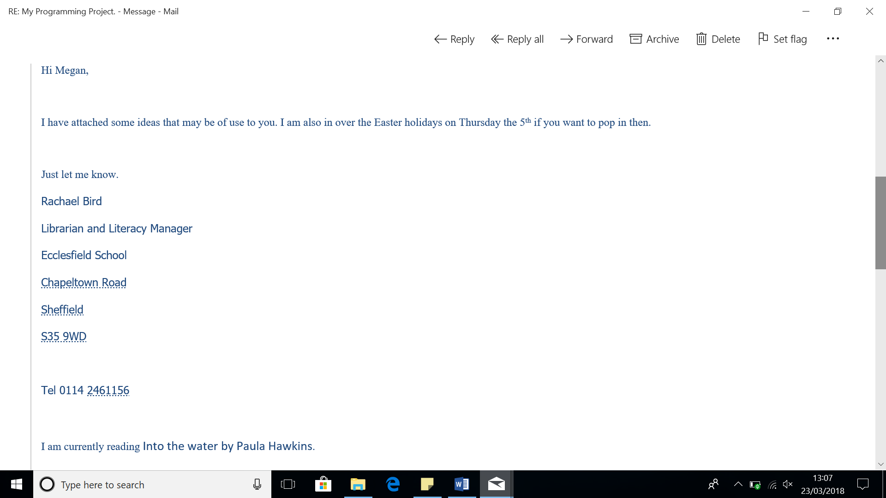

The idea of using a different font that is easy for the users to read is very much an option that I feel I will be able to implement, however I throughout my 1st phase as I have the students test my program I will change the font seeing which one they feel they can use the best.

This is viable as when setting up the programme I will set the colour to an off white as default (currently).

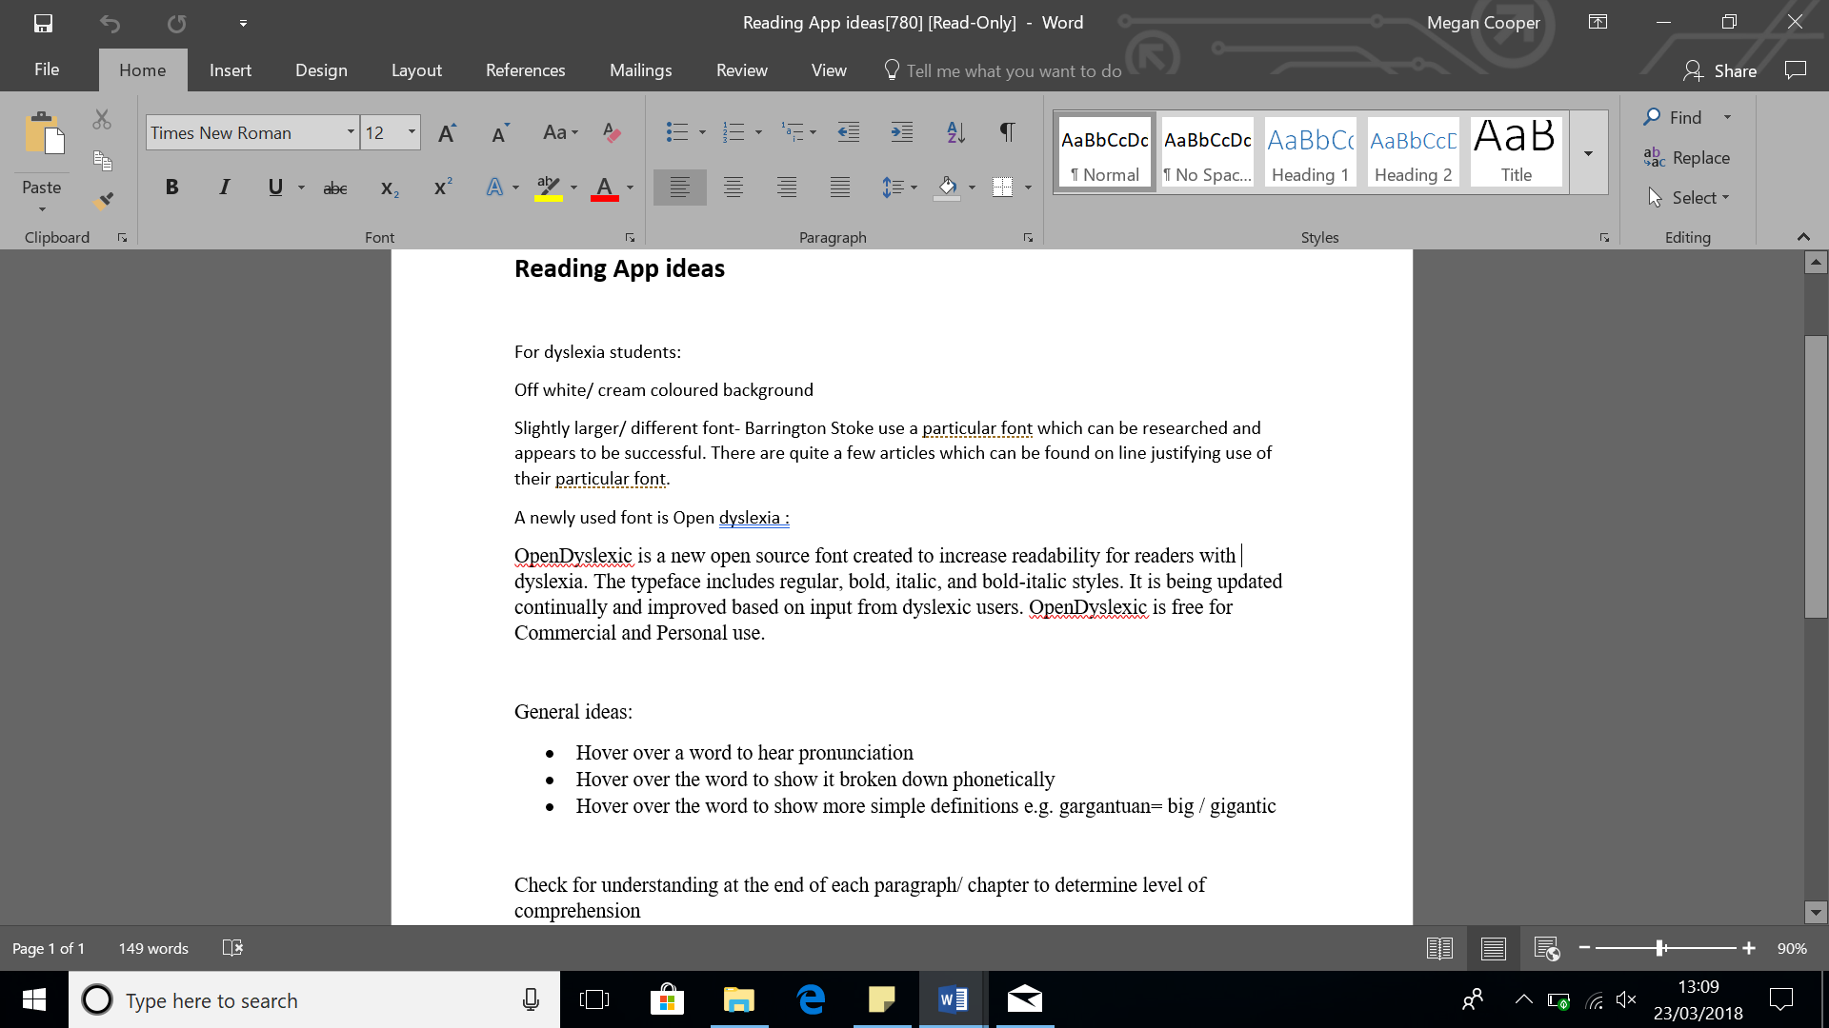

After speaking to my teacher, I have concluded that the 1st point will be easy to implement as I can use the “google text to speak” library AKA TTS which I will need to look in to how to use. However, points two and three many be more difficult to include as it will depend on the libraries that I can gain access to and use.

For this I will need to wait until I have had a more in-depth meeting with the teacher to see what sort of things they suggest implementing here before I can decide.

##### 2nd Meeting:

Because of unforeseen circumstances the original date of the 5th of April became inconvenient for the stakeholder, so the date of the meeting was moved to the 9th of April. To begin me and the teacher, started by expanding some of the points provided in previous communications. We initiated the meeting by starting with the idea of checking for comprehension. When discussing what sort of prior way’s, the students were used to check their understanding of a block of text, common ideas were small vocabulary test, making sure that they have understood the words used in the passage/work they are reading also the idea of being asked simple questions about the passages they have read was common. However, at this stage within my development I am not sure as to how to implement this, so it will require further investigation,

Furthermore, after speaking to the teacher I am considering using something similar Microsoft office’s use of synonyms as this offers a way in which complex words can be simplified. For example, gargantuan can be broken down to enormous, which can then be broken down to massive and then again to huge. Although, this is an idea that I am going to research into to see how feasible it is. Finally, the teacher and I spoke about possible visual aids for the application, for example being able to change the background colour from off-white to other colours such as pink, blue, green and a pure yellow. Furthermore, the use of a line or arrow which keeps track of where the students get to when either reading a document or PDF.

##### 3rd Meeting:

This meeting was only a short whereby we could clarify what the students were wanting with the understanding of comprehension (Yellow Box on above screenshots). For now, I have decided to keep this in phase one however, it will not be an essential feature and thus I may choose to remove this at a later date as once I had spoken to the group I determined that they wish to have a small section of the PDF that they have read, and questions to be generated from this o check the basic understanding i.e. if the text referenced a character using a red ball a question could be ‘What colour ball did X have?’ then the students would answer and it would check the inputted answer against a pre-stored answer and state whether or not the answer was correct.

#### Essential Features:

* Must be able to handle user inputs via touch,
* Have a default off white background,
* PDF viewer
* Word pronunciation (Google TTS)
* Side bar that keep s the features organised

#### Optional Features:

* Choice of screen colours,
* Synonyms,
* Text editor,
* Checking comprehension

### Limitations:

#### Language:

* + To simplify the programming as I am of a novice programmer this application will only initially process English and no other languages such as Welsh, Scottish Gaelic and other languages used by those who use English as there second language (ELS)002E

#### Limited mobile device support:

* + Because of there been little to no cross over between android and iOS I will only be programming for android. IOS includes very little support for Java and hence the runtime would need to be completely redesigned for iOS

#### Limited web device support:

* + Because I am designing this as an android mobile application it will not be web browser friendly as the platforms are different and I also want this to be accessible on the go therefore it should not require an internet connection.

### Requirements:

#### Android Studio Requirements:

##### Windows OS

* Microsoft Windows 7/8/10 (32-bit or 64-bit)
* 8GB RAM recommended however 2GB will suffice
* 2 GB of available disk space minimum, 4 GB Recommended (500 MB for IDE + 1.5 GB for Android SDK and emulator system image)
* 1280 x 800 minimum screen resolution
* JDK 8

#### Phone Requirements (hardware devices been used as

##### For general testing:

* + Samsung Galaxy S7 (SM-G930F):
    - Hardware:
    - Software:

### Success Criteria:

These are the specific success criteria for Phase one:

* The application must open on the Samsung galaxy S7 as a minimum.
* Each of the elements are required to work independently:
  + *Default off white background*
    - For this to be a success the background of 80% of my applications must be on a pale yellow, which will be predetermined
  + *The option to swap the colour of the background*
    - For this to be a success the all button options must work 100% of the time and the colours it changes to it must match what is said on the button i.e. if the button says red then the background will change to red if pressed. The user must have the minimum of five colours including the default of a pale yellow.
  + *A PDF viewer,* 
    - For this to be a success the PDF reader must allow for the user to choose the PDF that they want to open and then further allow for the movement within this PDF, this will only be successful if it completes as that with little to no lag at 90% of the time thus allows for some margin of error.
  + *Word pronunciation (Google TTS)* 
    - *This is only be a success if it reads what the user has entered with a clear voice/tone/pitch. Furthermore, this must work 100% of the time no matter how many times the user hits play or changed the text. It must allow for large bodies of text.*
  + *Synonyms* 
    - *This will be successful so long as it provided a minimum of three alternatives for the user dependant upon the word the user has pressed. It must complete this 100% of the time unless there it is unable to do so as a result of there only been one/two other possibilities.*
  + *Text editor*
    - *This will be successful so long as the user can input mass amount of data of all forms i.e. String, numbers and symbols 99% of the time. It must also allow for the saving of these files as a .txt 100% of the time if the Save button is pressed. Finally, it must also allow for the opening of the .txt files back into the application 100% of the time.*

### Algorithms:

#### Text editor flowchart:



#### Background Colour Changing Flowchart:



Text to Speech:

## Design:

Screen Designs: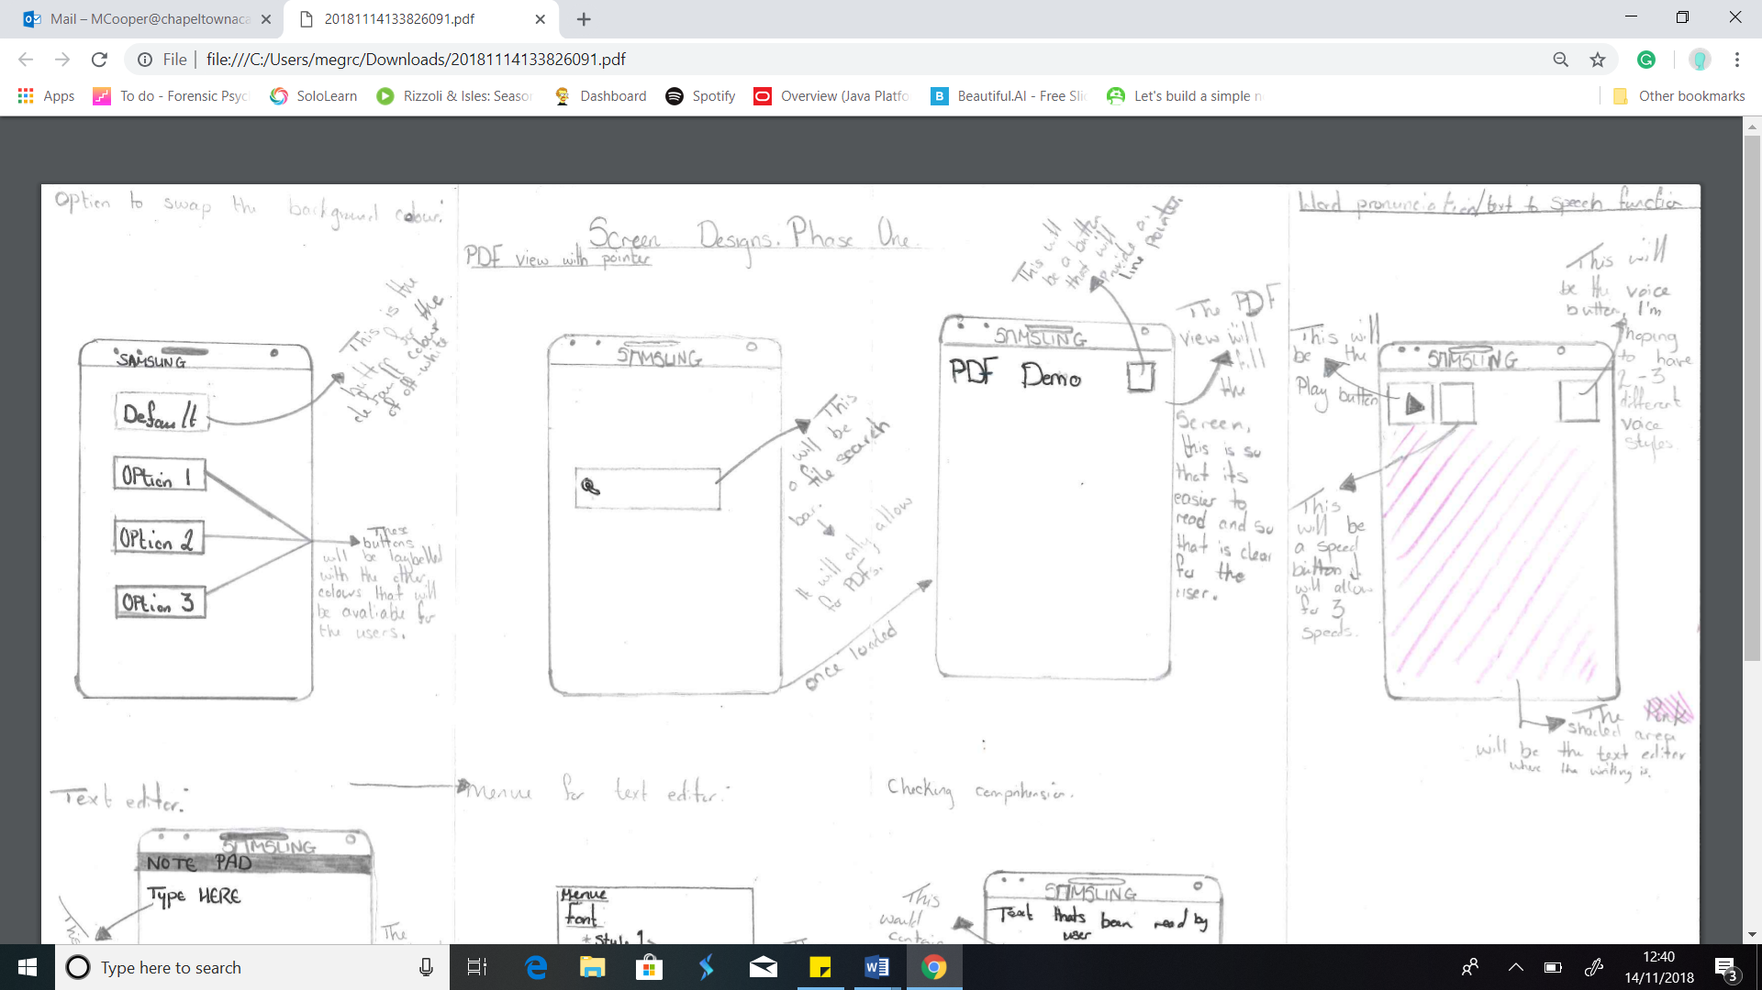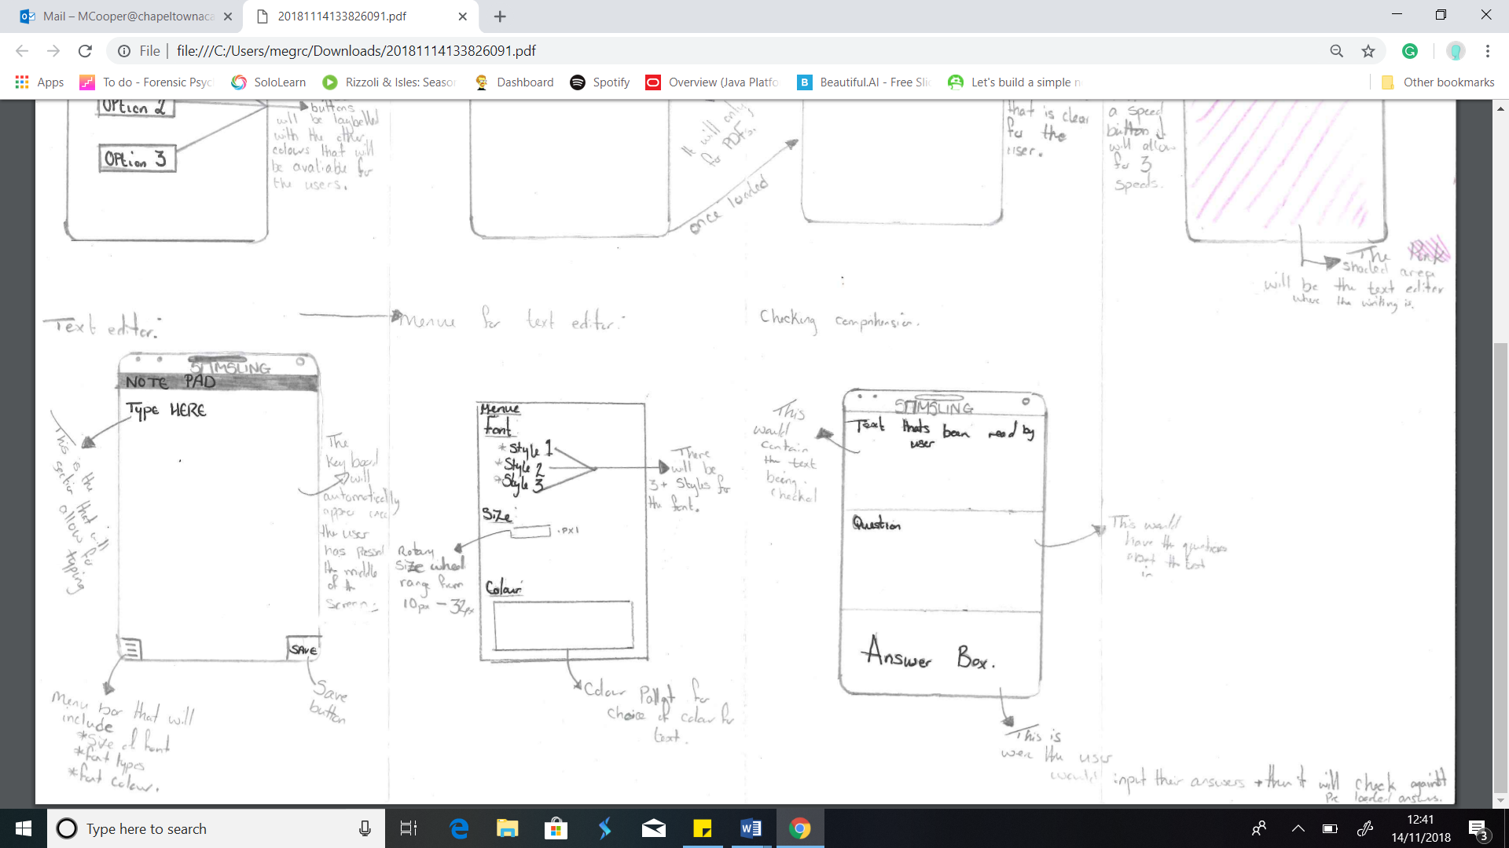

### Test Plan:

|  |  |  |  |  |
| --- | --- | --- | --- | --- |
| Test Num: | What’s been tested? | Data entered. | Expected outcome. | Actual outcome. |
| 1i | The application will change the background colour. | Default button pressed | The colour will change to the default of a pale yellow. |  |
| 1ii | Blue button pressed | The background with change to blue |  |
| 1iii | Red button pressed | The background will change to red |  |
| 1iv | Green button pressed | The background will change to green |  |
| 1v | Pink button Pressed | The background will be changed to pink |  |
| 2i | The PDF viewer opens. | N/A however the application must be able to open on the Samsung galaxy. | The application will open and will stay open, with a PDF file of choice. |  |
| 2ii | The PDF viewer opens the selected file (PDF’s only). | A PDF file selected, which is then loaded on the screen. | The selected PDF document will open on screen and be readable to the user. |  |
| 2iii | If the button is pressed the pointer appears on the screen. | Button press | The pointer will appear on the screen, once the button is pressed. |  |
| 2iv | The pointer moves accordingly. | N/A | The pointer will move to the line a user presses at the beginning of that line. |  |
| 2v | The PDF closes when the user wishes | Home button is pressed | The PDF closes when the user closer it not when it wants. |  |
| 3i | A text editor opens | N/A | The text editor will open without crashing. |  |
| 3ii | The background is on its default pale yellow setting | N/A | The background colour will stay as pale yellow when loaded |  |
| 3iii | The option to change text features e.g. size | Size wheel/ buttons that correspond with the text size. | They user will be able to change the colour, size and font using an option pane. |  |
| 3iv | The text file saves | Save button pressed | The file will save, the file name will be the same as the title on the document and the user can chose were the file is saved in a documents folder. i.e. a secondary folder named History. |  |
| 3v | Opening of saved text files | Open button pressed | A small file directory/ explorer will open, when the user presses a .txt file, it will open in the text editor with the settings of their choice. |  |
| 4i | Synonyms checker in .txt file | Long press on a word in .txt file | The users will be able to long press a word and a small list of synonyms should appear for the user, this should not affect the other data in the .txt file. |  |
| 4ii | Synonyms checker in .pdf file | Long press on a word in .pdf file | The users will be able to long press a word and a small list of synonyms should appear for the user, this interaction should not affect the PDF. |  |
| 5i | Word Pronunciation (TTS) Text input | Should allow for the entry of text | Text of all forms allowed to be entered.  Test data should include: “Hello World.”  “ 123”  I will also test with a long paragraph of text. |  |
| 5ii | Word Pronunciation (TTS) Speech | Button pressed | If the speech button is pressed the text in the editor should be read aloud. |  |
| 5iii | Word Pronunciation (TTS) Pitch + Speed changing options | Button pressed or scroll wheel | If the user changes any of these values the voice will change accordingly i.e. if the pitch value is increased the voice pitch in increase in the correct way. |  |

## Implementation:

For this phase the implementation will be split into the different functions of the application will have as previously described in the analysis. Therefore, it will be small sections of the program ready to be combined in phase three, thus it may miss some of the success criteria as for some of the criteria it needs to all be implemented together. Because of my lack of knowledge of Java programming and how to use the Android Studio integrated development environment (IDE) many of the problems through the development phase were as a result. Although, many of these problems were solved once I had done the appropriate research i.e. using YouTube, stack overflow and the ‘developer.android’ site to provide explanation were needed. All issues found and fixed will be discussed with relevant screenshots and explanations in this

### Colour Changer Screen:

When I first started programming this function of the application my initial steps were to speak to both my stakeholders and those whom work in the SENCO units with in the schools that my stakeholders attend to gain an idea of what colours are used with those who struggle to read from a white background. See initial email exchanges with R Bird in stakeholders’ section for first ideas. However, I concluded that including all the current possible colours would be too many for the user-friendly layout I want and not all of the colours are replicable to the same capacity so look to be a different hue therefore, they are not as affective for the users. As a result, I will only be including the most predominately used colours. These consist of off-while (pale yellow), pale blue, pale pink, pale red, pale green and pale pink. I will also potentially be adding a white background option for those such as my ESL target audience.

There will be no main home page to interact with at this moment. As, it will not be a complete application until the end of phase three. For the changing of the screen colour the feedback from stakeholders will be completed using verbal feedback and email communication via Mrs Bird. At this point communication will only consist of screenshots of the working project as to save time with arranging meeting with all stakeholders and keep the interest of all involved as some of the smaller requirements of my application will be very simple and basic thus making it tedious for long meeting and for some of the stakeholder groups to be seated in order test the program by pressing the button which will change the screen colour. Therefore, most of my stakeholder feedback will come in phases two and three as I merge all features together. However, as I want to be able to test the features as I go so that there is not as many bugs to sort at the end of each phase thus reducing the time required per phase, I will be getting regular stakeholder inputs and all three groups testing throughout.

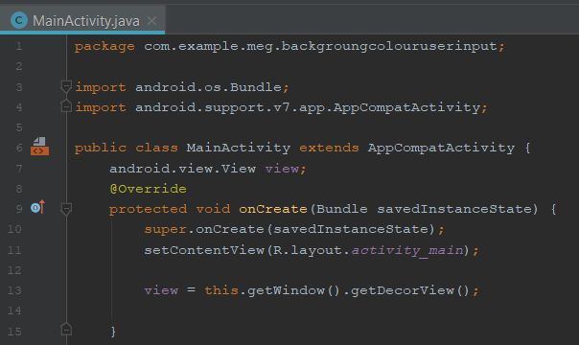

Figure 1 - Java code for the initial colour changing function of the application.

The above code was completed as a tutorial as I was new to both java programming and how to use android studio, however once I had finished the code I realised that this wouldn’t do what I needed as it only changed the outer edged of the screen. Failing to change the full background colour. Furthermore, the tutorial that I was following didn’t allow for any user input thus I couldn’t change the colour which became a concern when looking at the screen design and blueprint. This was further confirmed when I ran the application on the Samsung S7. Thought the development stage of the phase I received an upgrade to the hardware that I was using for testing (From the Samsung S7 to the S9). As a result, I no longer had access to the S7 phone, meaning that all testing completed from this point was completed on the S9. Upon looking at the code I realised that I failed to create any methods for the other colours, furthermore, I used the line of code ‘*andriod.view.View view;*’ which is the line of code which controls the section of code which changes colour. The ‘android.view’ is what made the code change the outer edge rather than the centre of the screen.

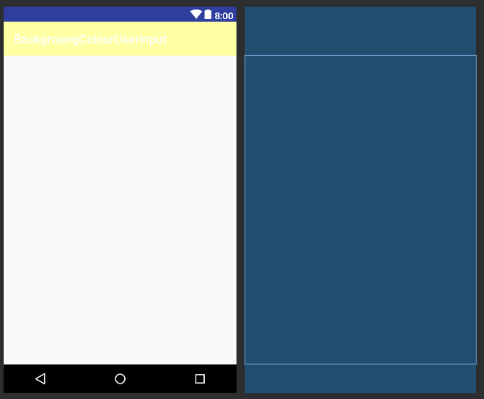

Figure 2

Figure two shows the design view for the initial colour changing application on the left-hand side is the design screen and on the right-hand side is the blueprint view of design. As can be seen only the outer edge of the screen was changed and there were no elements such as buttons or text views for which a user could input data. However, after further research I found a way of creating buttons which would allow for the user to decided which colour they would like and change the background. I also fixed the issue so that it will change the main screen rather than then edge.

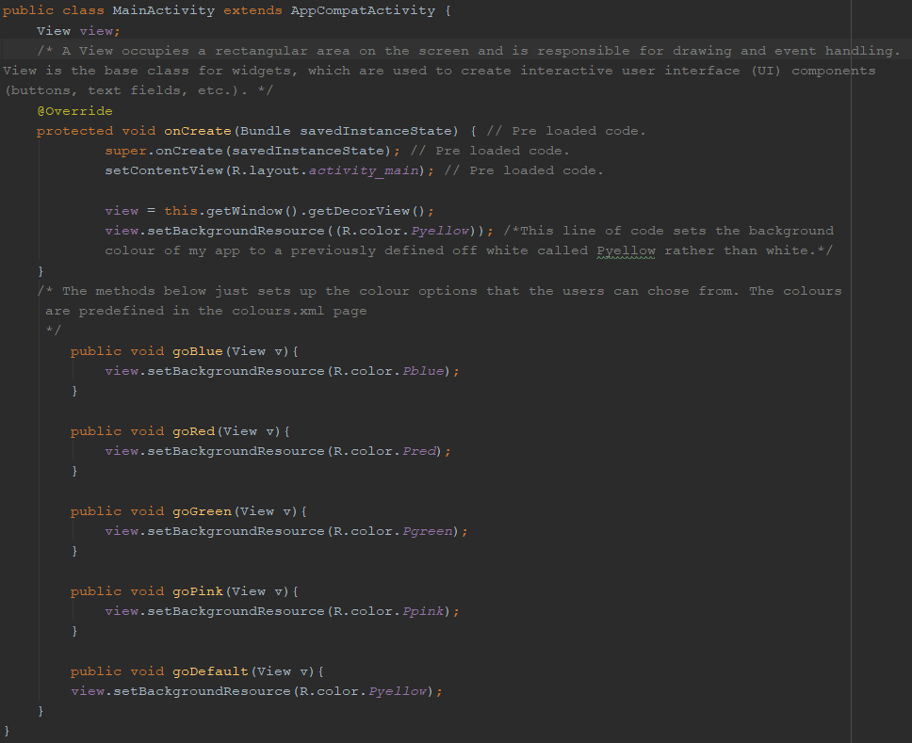

Figure 3

Figure 3 is the fixed code, as can been seen there are additional methods with have a link to both a single colour and a button that the user can press on screen in order to have their chosen screen colour.

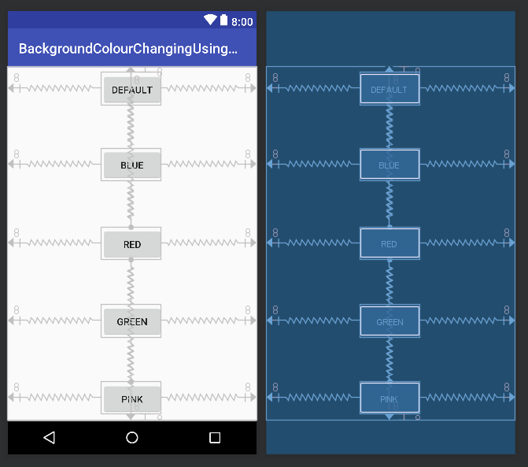

Figure 4

Figure 4 shows the new design, as can be seen there is now five button each one links to a single colour. I have also spaced them out as equally to make this as easy to see as possible. Furthermore, I have left a bigger space than required between the buttons as it should make it easier for those using the application to press screen colour they want to use should any of the users have a condition or requirement that means they may struggle with using buttons on a touch screen. To check that the stakeholders were okay with this layout I took a copy to various stakeholder meeting as Mrs. Bird felt that this would be a good time for me to introduce myself in full to the group. After discussions in smaller groups and test runs on the Samsung S9 I gained feedback from the students who all agreed that this layout would be ideal as it was clear and easy to use. Frances my other stakeholder further agreed and found that having the buttons in the centre of the screen very useful. I also asked the ESL group their thoughts as while this feature will not necessarily be used by them I wanted them to see what other features exist on this app. Furthermore, I may add an addition button for a plain white screen for those who do not require the background to be of a different colour.

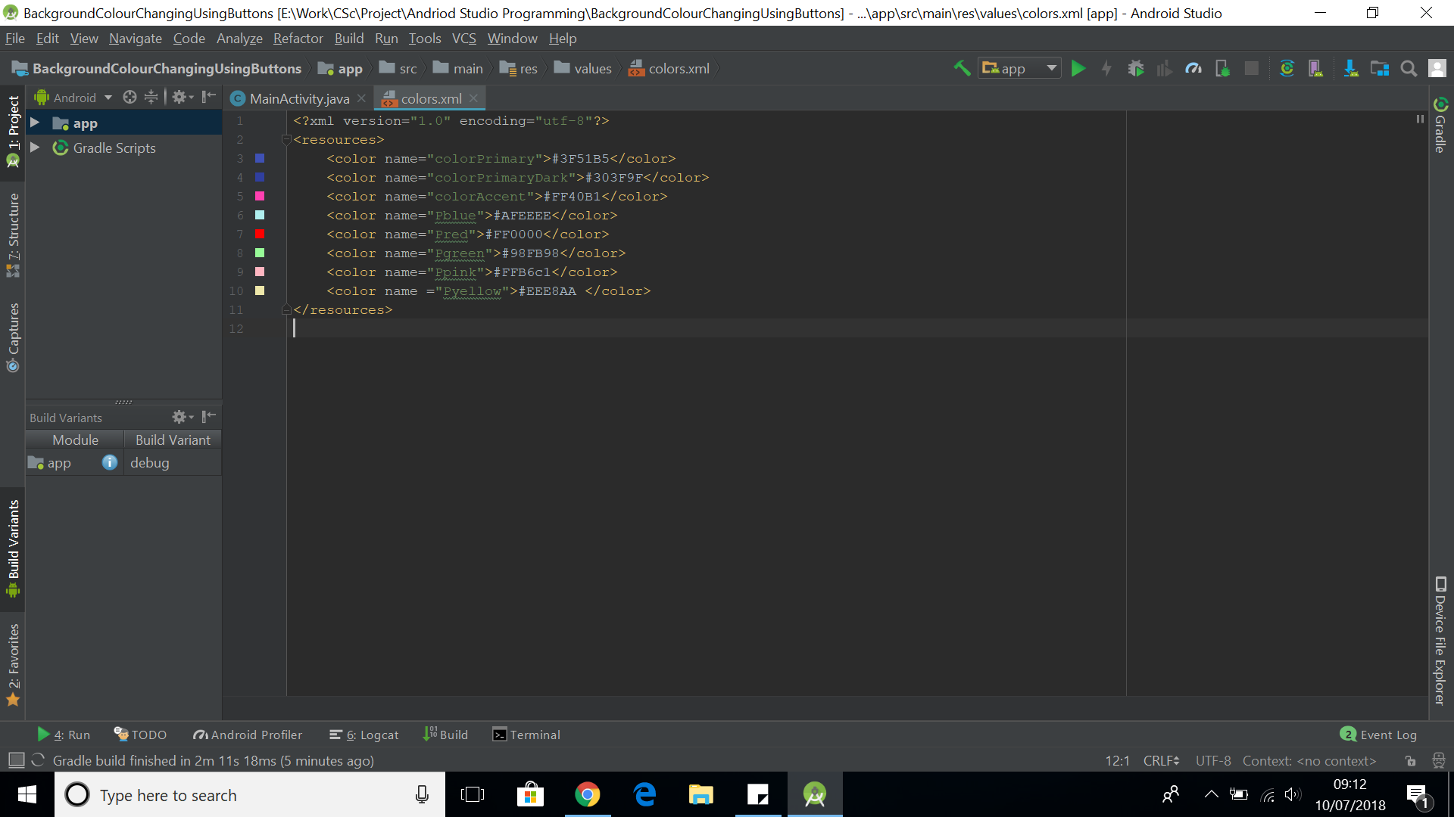

Figure 5

Figure 5 shows the Hex Code for the colours I’m planning on using. The top 3 are default colours that are pre-programmed into Android Studio. Pyellow will be the default back screen that I will be setting as it is the most common colour used by those who have dyslexia and struggle with their reading. As seen in the current paper solutions available.

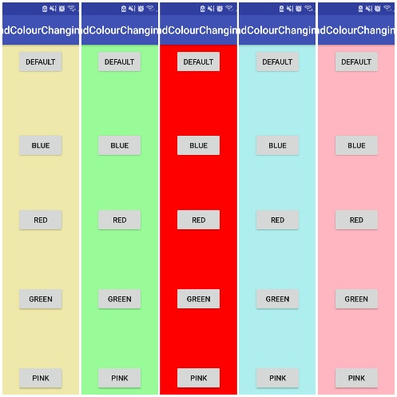

Figure 6

Figure 6 shows the colours once loaded into the app. I’ve created a collage of the colours so that it was easier to see all the colours side-by-side. I also sent individual screenshots of the colours to Mrs Bird as this was a task in which I though the stakeholder groups may find pressing the buttons and providing feedback to be a tedious activity thus, them losing interest. The feedback I was received was that the colour options I have chosen are good with a nice range however the red is too bright/ deep thus most of the students felt that the text was not clear enough and the background colour was too distracting. So, I have changed the shade of red however when doing so, I received the following error.



Figure 7

This occurred as I had added an additional hash to the colour Colour.XML file which was not needed. After removing the hash symbol, it fixed after recompiling. Below is the new hex code for the shade of red.



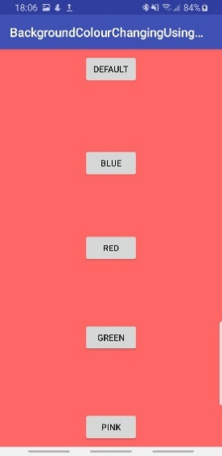

Figure 8

Figure 8 is the screen shot of the new shade of red, both stakeholders one and two agreed that this was a lot better as it wasn’t as bright thus it wasn’t as distracting.

### Simple Text Editor:

For this initial phase I’m going to make a very basic text editor that will be expanded upon in phase two of the project because of timing issues both in the side of the programming and stakeholder meeting availability. Before starting this, I drew up a template of the simplified text editor to show the stakeholders. Because of timing for the diagrams, I only spoke to stakeholder F and M. They agreed with how I was wanting to lay it out however said that they struggled to picture what the final screen would look like, so we worked on designing the screen on a new android studio programs which I would then code around. This was further time saving as it meant that I wasn’t required to schedule a further meeting to see if the layout was as the stakeholders wanted. Frances further agreed with the screen design.

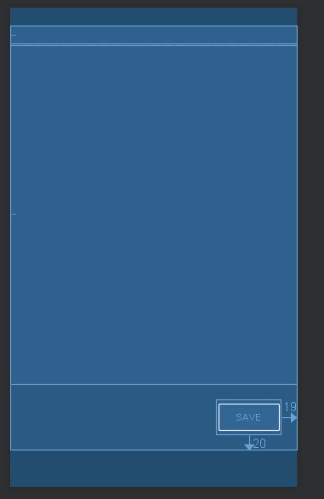

This will be the header which will contain the name of the file as it saves. E.G. If the header says ‘English key themes R+J’

This would be the main body of the text editor, for phase one this will allow the users to enter simple text in a single font.

This is a save button, it will save the file to a default location, however in phase two I will change this so that the user can choose where it can be saved.



Figure 9

While figure nine is a very simple diagram it helped the stakeholder picture where everything would be on the screen, they suggested that the save button be on the bigger size. All stakeholders agreed that having the save button at the bottom of the page made it clearer to see. Thus, they said that if I add any further functions such as open that I they’d prefer it to be at the bottom of the page or if I place it all into a sidebar that I should make the icons large and easy to read similar to the current buttons.

When programming this I found it very difficult to find a starting point as Android Studio was still new to me. So, I started by having a quick look at current available solutions that others had already created. This brought up many solutions although non-had every function I needed, this has meant that I’ve had to research some of the more specific features that I want.

Figure 10

The image to the left is the first test of my text editor. As it says the colours clash too much, which my stakeholders agreed with. Furthermore, when testing this out I found that the save button didn’t work and it also wouldn’t turn landscape.

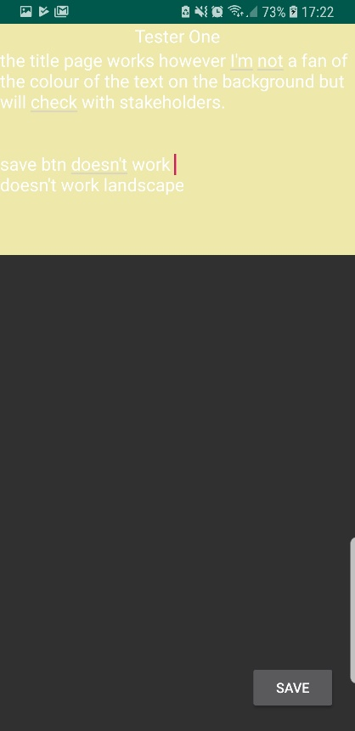

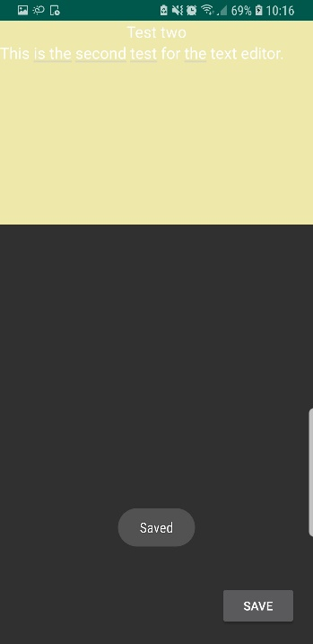

I fixed the problem of the save button by adding permissions to the manifest file of the project.

“<uses-permission android:name="android.permission.WRITE_EXTERNAL_STORAGE"/>

Figure 11

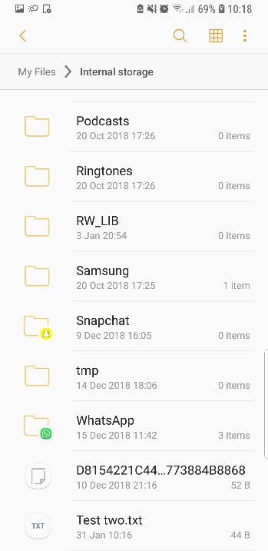

Figure 12

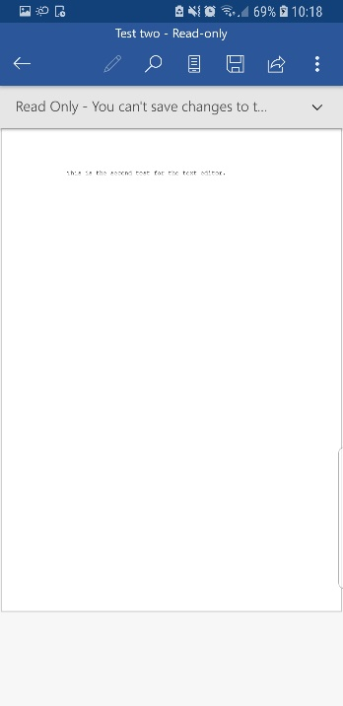

Figure 13

The above images show my second test of the text editor feature. Figure eleven shows the application open on a Samsung S9. It clearly shows the separation of the text edit section and the area where the user is able to save the file. Figure twelve shows that the file has saved into the external file folders. The file name is the same as in the ‘banner’ which was agreed by all stakeholders as been the most beneficial way of naming such files as it involves less buttons and instructions thus less complex. Figure thirteen is the .txt file open in a different text application this is an issue I plan on solving later either in this phase or as an addition to phase three depending on timing. For this I’ve managed to get the save button to work however, currently there is no choice as to where the file saves to as seen in the above images, however, I’ve decided to add an open function to this, so I’ve had to research how to get files from external storage. Furthermore, for the next test I’ll be changing the font colour to default black. I will be adding the option to change font size and colour later, depending on timing I may also add the option to change the text font as previously planned although these are not essential features at this moment and could be added for later releases should other issues be found in this phase.

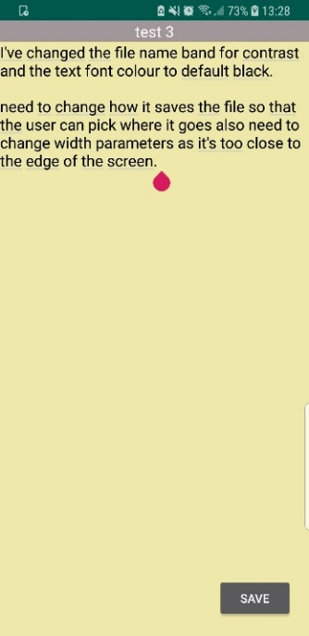

For test three I didn’t change much but rather I found other design flaws that the stakeholders didn’t like. For example, when meeting with stakeholders 2 the group didn’t like that the text went all the way to the edge. Especially on the more modern android phones which have a curved screen – like the Samsung S9. Stakeholder 1 further suggested that the file name banner at the top be in a different colour, which stakeholder 2 agreed with thus, I changed this while in the stakeholder meeting as it was a quick fix. The stakeholders decided that grey was a good colour as it contrasts well with the default background colour.

Figure 14

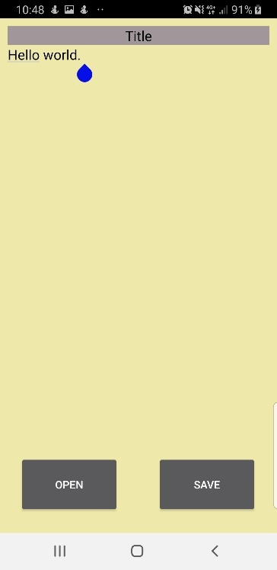

This just shows the changes that were made to move the text away from the edge which was done by adding a padding of 10dp. I’ve also added a button for opening a txt file however this doesn’t have any code for it yet, so this does not work.

Figure 15

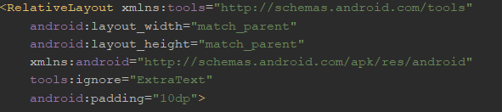

Figure 16

Figure 16 shows the simple rectifications I have made by adding the ‘android:padding=10dp’ so that the text is no longer at the edge of the screen. This suits some of the more modern phones in particular as they have curved edges of the text was warping all the way around making it very difficult to read. All stakeholders agreed the having the small padded area on the edge of the screen helped significantly with clarity. After sorting the design of the text editor with the Stakeholders inputs I started working with open button.

### PDF Viewer:

The initial development of this section of the application is a PDF viewer that will allow PDF’s to be chosen from and opened within the app. To begin with I used a tutorial which went step by step through how to create such application in android studio, (<http://www.uandblog.com/How-to-Create-PDF-Reader-Application-in-Android>). However, when I first ran the code I received the following error.

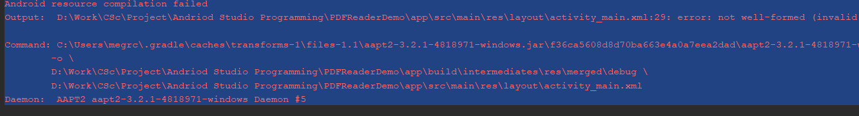

Figure 17

I thought that this was a result of not adding the permissions which allows access to external storage such as Secure Digital (SD) card, for the PDF files. However, even after adding the permissions for this it still didn’t work so I resorted to first looking at Google to see it others had had the same problems. I soon found out that one potential reason that this may have happened is because my program was unable to resolve symbol R within my code – an error that can be caused by an error in the XML files. Figure 18 shows where the error was within the design XML layout.

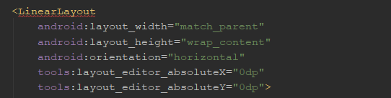

Figure 18

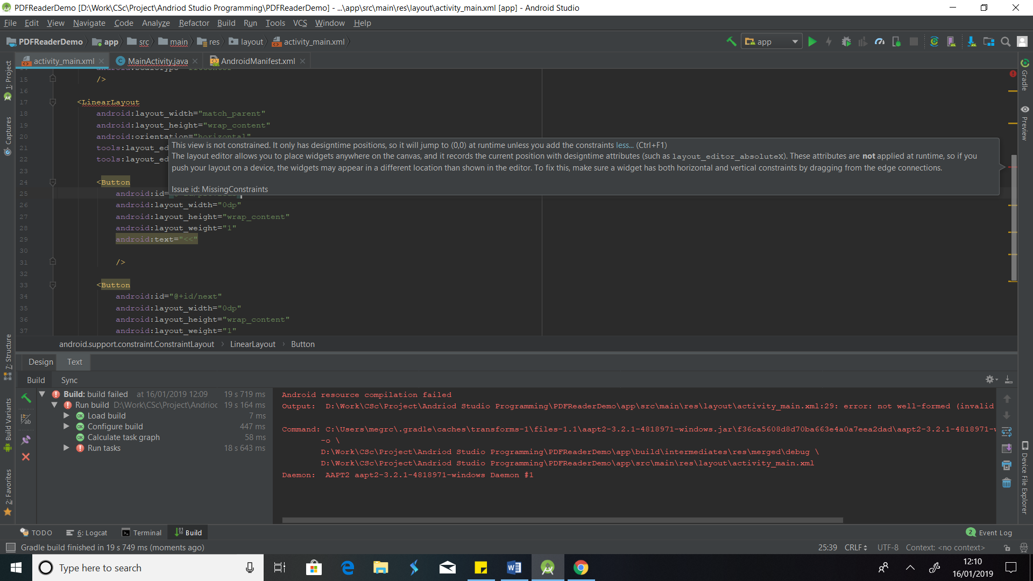

Figure 19

I fixed this code by using the suggestion that android studio offers when pressing key Atl + Entr on a keyboard when hovering the cursor where the red line is. However, after a clean build this still failed to fix the error with R symbol. I then tried a rebuild rather than a clean build – which again failed so I turned back to google as when asking another student in the class who was also working with Android Studio we still couldn’t decide what was causing the error. In the process of trying to fix the error for the R symbol I realised that the permission I added was in the wrong syntax form so changed this.

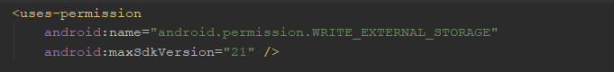

Figure 20

New permission code depicted in figure 20. However, this still didn’t work so I began to research more solutions for making a PDF reader and found one that will allow me to open one PDF of choice thus I have decided to use this as a base for the PDF viewer I am making.

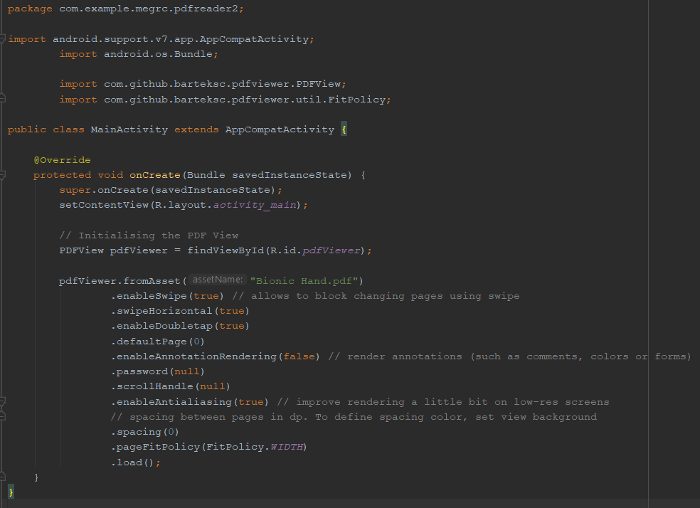

Figure 21

Figure 21 shows the code for the PDF viewer, this is currently limited in its functionality as it only opens a single PDF that’s been predetermined. However, the PDF viewer allows for the pages to be moved via scroll rather than use of buttons which means that the whole screen can be used for the PDF rather than requiring it to be made smaller in order to allow for the button i.e. if I was to add arrows they would need their own space as not to interfere with the text on the PDF. This would be unsuitable as the groups of people that this is aimed at already struggle with reading and the English language. However, to check that was adequate for the users I got all three groups to test the this with the pre-selected PDF at this time. All three agreed that not having the buttons there made it significantly better as they were able to use the whole screen. While I did not program the options to have the buttons due to time constraints I have created a blue print to what the screen would look like if the buttons were there.

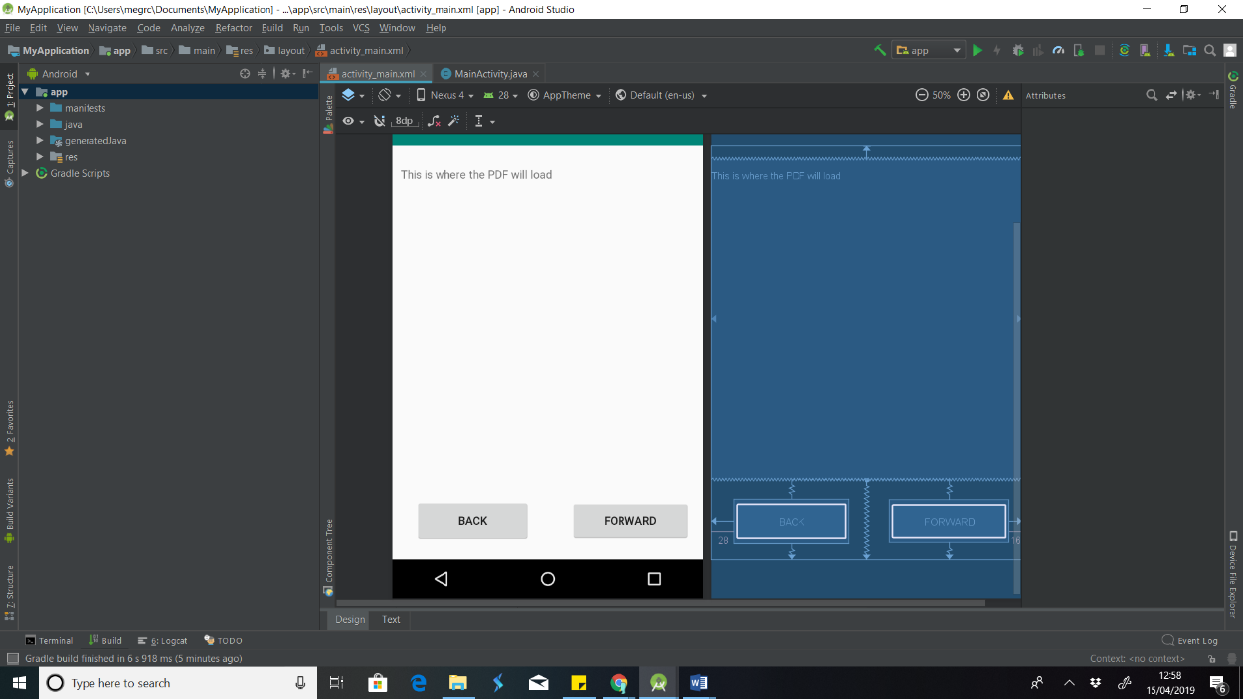

The screen design that I’ve used to show all three stakeholders as can be seen in the blue print section the users lose a fair amount of the PDF screen as there needs to be adequate spacing around the buttons so that it doesn’t merge with the PDF area for clarity as requested by the Stakeholders.

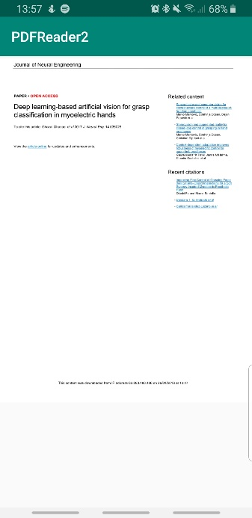

Figure 22

Figure 22 shows the first page of the PDF documents that I have pre-loaded, for the current testing as in my initial attempts to follow any of the tutorials I had no output on the screen of any kind. As can be seen in figure 22, the PDF document loaded successfully on the Samsung S9. However, currently the document is cutting off about two thirds of the way, meaning that it isn’t using the full screen.

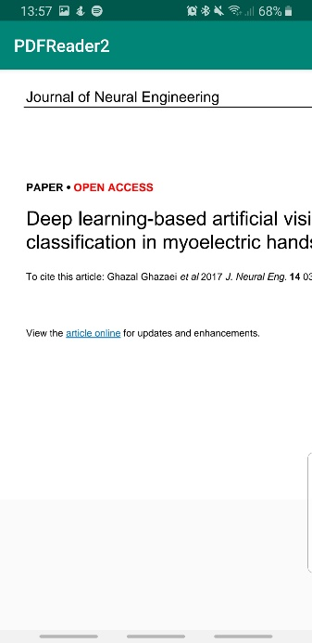

Figure 23

Figure 23 shows the exact same, first page however I have zoomed into the top left corner using a pinch zoom. When showing the stakeholder one and three, as I was able to arrange meeting with both in the time needed, they both agreed that this was a simple enough action as I suggested other options for zoom such as buttons or a seek bar. As can be seen on the development of screen designs included below – these were further developed using the android studio .xml area after the design section of this phase hence they have been added in here. 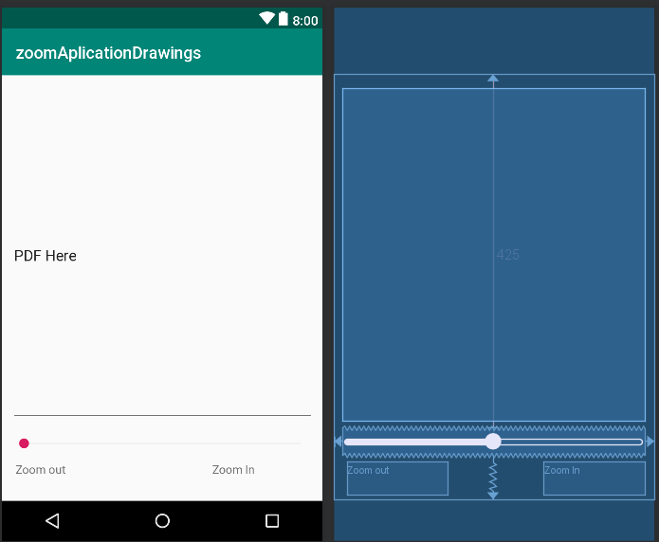

Figure 24- PDF with seek bar for zoom

These are the buttons that would be used for zooming in and out of the PDF. They would have a plus and minus sign on them thus would not need labelling unlike the Seek Bar.

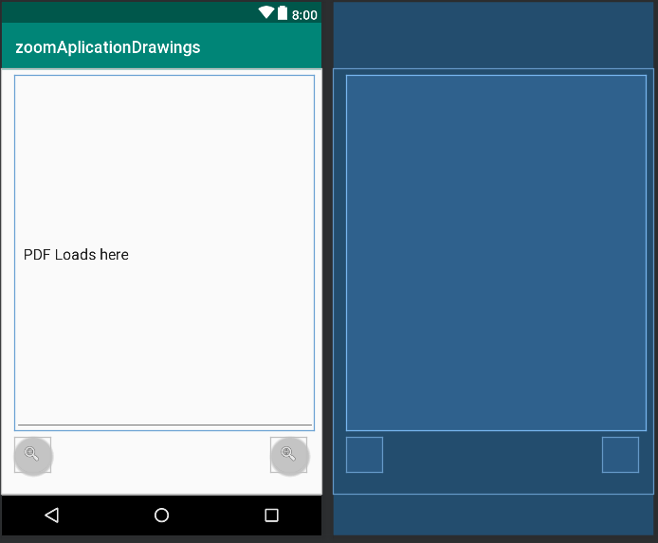

Figure 25 - PDF with zoom buttons

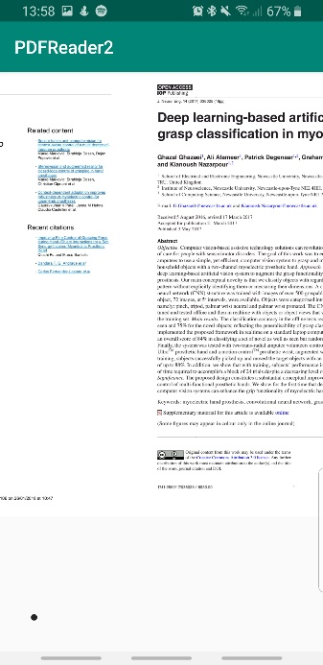

Figure 26

Figure 26 is a screen shot of the PDF document in the app, scrolled between two pages, it shows half and half as to show that it can be moved back and forth. While the image doesn’t show it, this was completed by scroll as previously discussed. After I had the basis for the PDF reader I began to work on how to have the user choose the PDF document that they want to open.

### Text to Speech (TTS):

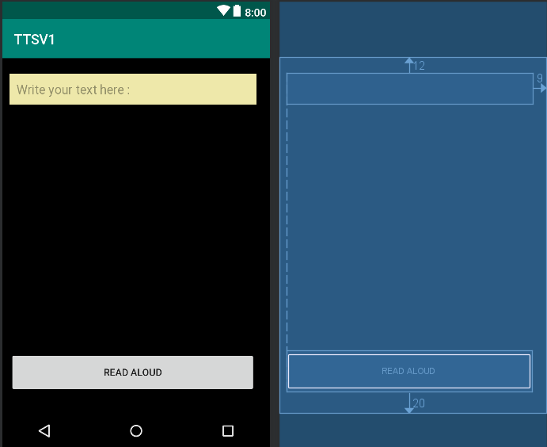

This is the separate text to speech function and while the text box section looks very small, this is a result of me having the length set to the wrap-content size in the .xml file so that it changes dependent upon the amount of text entered.

I have further added the 10dp padding to this so that it was away from the edges similar to that of the text editor.

This is a simple button which when pressed the default voice will read out what has been typed.

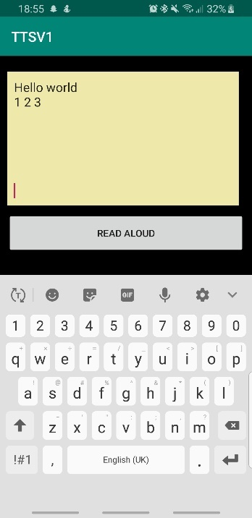

This is a full-length button that once pressed will allow the user to hear what ever has been types in the text edit.

To check that the edit text section (Yellow box) will wrap its length if there is a significant amount of text. This means that all of the text is in the same box, rather than the user needing to do it in small sections.

This is a screen shot of the text to speech feature on the Samsung S9, this shows the simple text examples that the user may enter. The top text entry shows how the user can enter a String type and the second line is to show that it can handle numerical inputs.

Figure 27

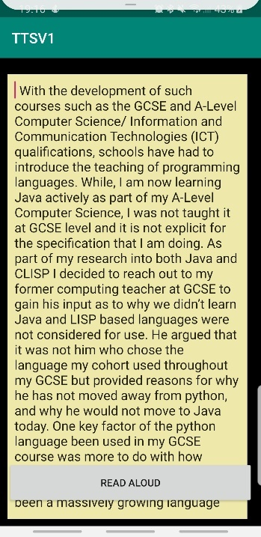

As a way of checking that the wrap-content for longer texts worked I simply copied and pasted a paragraph from a text document that I had previously been working on. As can be seen in figure 28 the edit text expanded as far as it can go within the padding setting I have predetermined. Furthermore, this has a scroll function that allows the user to scroll so that they can read all text entered. See video in table two to see this happening .

Figure 28

Refer to video table two to see the text been spoken out loud. As seen in video two the default voice is able to pronounce the words in a clear way. Furthermore, when reading out the numbers it doesn’t faulter and it understand the numerical value. Finally, it can handle large bodies of text, with clear stopping for the punctuation. However, I found that the speaking didn’t not stop even if the application was closed unless the user completed a full close by stopping it from running in the background.

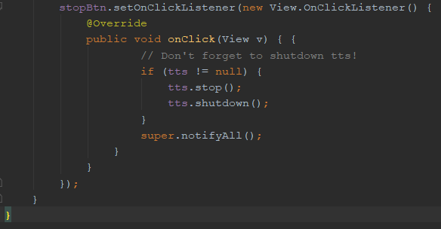

Figure 29

Figure 29 shows the code I added so that if the user pressed the Stop button the voice would stop. However, when running this it stopped the voice but also closed the application which is not beneficial for any of the stakeholder groups as it means that they are currently required to re-open the application if they want to continue using the program with different text.

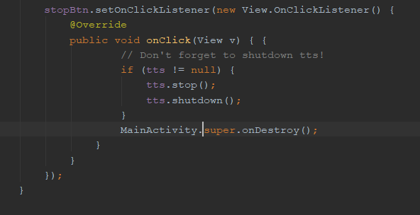 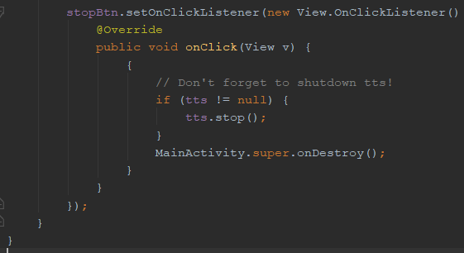

Figure 30 Figure 31

I changed some of the code, see figure 30 and 31, which stopped the program from closing yet when I change the text entered and pressed read aloud, it presented the toast notification but failed to read it out. After changing where the “tts.shutdown();” multiple times I tried to just remove it which works. This means that the user is now able to stop one block of text and change it and then have that read out without needing to close the application.

## Testing:

|  |  |  |  |  |  |
| --- | --- | --- | --- | --- | --- |
| Test Num: | What’s been tested? | Data entered. | Expected outcome. | Actual outcome. | Rectifications |
| 1i | The application will change the background colour. | Default button pressed | The colour will change to the default of a pale yellow. | As Expected (*See table one)* | N/A |
| 1ii | The application will change the background colour. | Blue button pressed | The background with change to blue | As Expected (*See table one)* | N/A |
| 1iii | The application will change the background colour. | Red button pressed | The background will change to red | As Expected (*See table one)* | N/A |
| 1iv | The application will change the background colour. | Green button pressed | The background will change to green | As Expected (*See table one)* | N/A |
| 1v | The application will change the background colour. | Pink button Pressed | The background will be changed to pink | As Expected (*See table one)* | N/A |
| 2i | The PDF viewer opens. | N/A however the application must be able to open on the Samsung galaxy. | The application will open and will stay open, | As Expected (*See table one)* | N/A |
| 2ii | The PDF viewer opens the selected file (PDF’s only). | A PDF file selected | The selected PDF document will open on screen and be readable to the user. | Currently the application only opens a pre-loaded PDF. (*See table one)* | I’ve decided that the choosing of a PDF will be added in Phase three. |
| 2iii | If the button is pressed the pointer appears on the screen. | Button press | The pointer will appear on the screen, once the button is pressed. | I haven’t implemented this at this time. | After talking to stakeholders, we decided that this was not an essential feature so will be added in phase four if time allows. |
| 2iv | The pointer moves accordingly. | N/A | The pointer will move to the line a user presses at the beginning of that line. | Not implemented | Refer to phase four if time allows. |
| 2v | The PDF closes when the user wishes | Home button is pressed | The PDF closes when the user closer it not when it wants. | As expected | N/A |
| 3i | A text editor opens | N/A | The text editor will open without crashing. | As expected (*See table one)* | N/A |
| 3ii | The background is on its default pale yellow setting | N/A | The background colour will stay as pale yellow when loaded | As expected (*See table one)* | N/A |
| 3iii | The option to change text features e.g. size | Size wheel/ buttons that correspond with the text size. | They user will be able to change the colour, size and font using an option pane. | Not implemented at this stage. | Refer to phase four if time allows. |
| 3iv | The text file saves | Save button pressed | The file will save, the file name will be the same as the title on the document and the user can chose were the file is saved in a documents folder. i.e. a secondary folder named History. | It allows for the file to save but doesn’t currently allow for the user to choose where. | I will be adding the option to save the file where it needs to be in phase three. |
| 3v | Opening of saved text files | Open button pressed | A small file directory/ explorer will open, when the user presses a .txt file, it will open in the text editor with the settings of their choice. | This isn’t currently implemented | Will be added in phase three |
| 4i | Synonyms checker in .txt file | Long press on a word in .txt file | The users will be able to long press a word and a small list of synonyms should appear for the user, this should not affect the other data in the .txt file. | Not currently implemented | If time allows this will be added in phase four. However, as I am adding a quiz for phase two based on words and those that often get muddled this may become a non-essential feature that would be added in a later release of the application. |
| 4ii | Synonyms checker in .pdf file | Long press on a word in .pdf file | The users will be able to long press a word and a small list of synonyms should appear for the user, this interaction should not affect the PDF. | Not currently implemented | If time allows this will be added in phase four. However, as I am adding a quiz for phase two based on words and those that often get muddled this may become a non-essential feature that would be added in a later release of the application. |
| 5i | Word Pronunciation (TTS) Text input | Should allow for the entry of text | Text of all forms allowed to be entered.  Test data should include: “Hello World.”  “ 123”  I will also test with a long paragraph of text. | As expected *(See table one)* | N/A |
| 5ii | Word Pronunciation (TTS) Speech | Button pressed | If the speech button is pressed the text in the editor should be read aloud. | As expected *(See table one)* | N/A |
| 5iii | Word Pronunciation (TTS) Pitch + Speed changing options | Button pressed or scroll wheel | If the user changes any of these values the voice will change accordingly i.e. if the pitch value is increased the voice pitch in increase in the correct way. | Not currently implemented | I was struggling to find a way to implement this in a way that would fit with the design my stakeholders and I agreed, as a result this will be added on phase three when combining all features together so that I have a better idea of the layout. |

# Phases Two:

## Analysis:

For this phase, I will be implementing the English based quiz which will test the . This will be a multiple-choice quiz which tests the users grasp of the English language, i.e. do they know the difference of ‘there, they’re and their’. This will be done either by asking for the definitions of the word or with the use of the question where the user is asked to provide the correct spelling of the work required to finish the sentence. For example, if the sentence given was “They were stood over …” the user would have to pick the correct ‘there, they’re or their’. This would be beneficial for the stakeholder groups I have identified as those with dyslexia commonly find that they jumble letters together so find that even reading a simple passage can be difficult thus with the quiz they will be tested on common words used in everyday English. This would be useful as it means that they will be able to recall these words when they see them in another context. This feature would further be useful for those who are ESL as for many grasping homophones is the part of the language which is the hardest as the English language has many words that either sound or look alike but that have different meaning.

### Success Criteria

For phase two to be a success the quiz must work with all its basic functions which are as follows;

* It must open and stay open every time it is opened (100% of the time)
* It must allow the user to have a question which will be displayed at the top of the screen 100% of the time. If must also change once the user has completed the last question .
* It must have a minimum of three options for the user to choose from 100% of the time no matter what the word is.
* It must track the users score, every time the user presses the button for with the correct score it must 100% of the time increment by one.
* it must be English based – this isn’t a measurable criteria, but it must only include questions that are English based

### Algorithms:

When looking at the possible algorithms I could use to code the quiz I had two possible options that I like the idea of and felt that with my current programming knowledge I would be able to implement, this was the Soundex Algorithm and a letter jumbling/ scrambling.

#### The Soundex algorithm:

Soundex is a [phonetic algorithm](https://en.wikipedia.org/wiki/Phonetic_algorithm) for [indexing](https://en.wikipedia.org/wiki/Index_(publishing)) names by sound, as [pronounced](https://en.wikipedia.org/wiki/Pronunciation) in English. The goal is for [homophones](https://en.wikipedia.org/wiki/Homophone) to be [encoded](https://en.wikipedia.org/wiki/Encoding) to the same representation so that they can be matched despite minor differences in [spelling](https://en.wikipedia.org/wiki/Spelling). The algorithm mainly encodes consonants; a vowel will not be encoded unless it is the first letter.[1] If I was to use this algorithm I would encode the words that I have placed in a separate ArrayList data structure, then compare and separate into words that are encoded the same. Below is the flow chart of an example Soundex algorithm.

#### Letter Jumbling/ Scrambler algorithm:

For this I would have predetermined an array of a range of pairs and single letters that phonetically sound the same or can be swapped/ confused, for example the sound ai and ay, or o and oo, or for those with dyslexia letters that have similar shaping such as c and o. Then the program would go through the chosen word looking for one of these which it would then swap providing it still make the word phonetically the same unless it is swapping an individual letter for the dyslexic option for the quiz as this will also have the similar looking words. For the flowchart I have used a letter jumbling java code and not the code I will be using in my program but the concept behind it is very similar. See the flowchart below.

Letter Scrambler flowchart;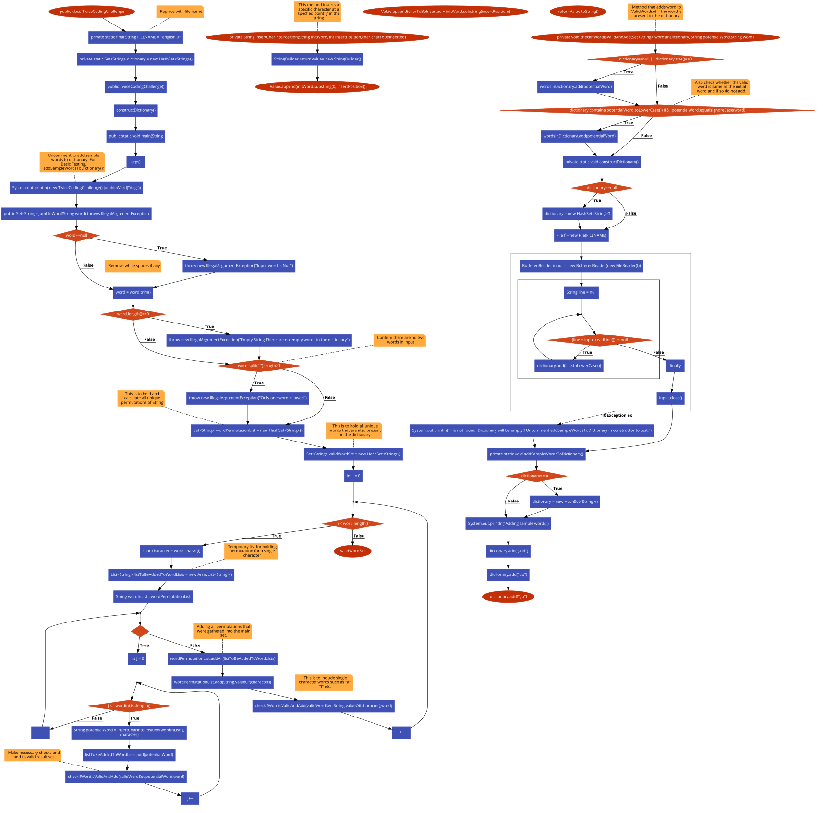

#### Soundex Algorithm flowchart:

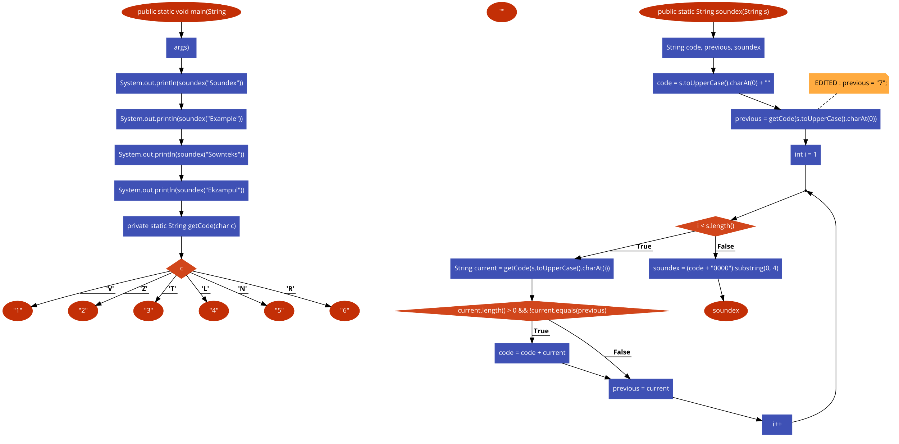

#### DictRandAccIndex Class Flowchart:



#### SubstQuizWord class flowchart:



## Design:

### Screen designs:

#### The Quiz:

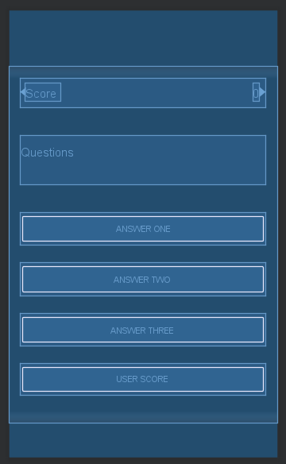

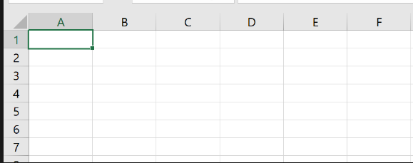

Figure 32

If the scores button is pressed, then the user should be taken to a comer separated value sheet with a list of scores. i.e an Excel spread sheet. I may also add an options screen for the different users, as both of my stakeholder groups would use this is slightly different ways as those who struggle with dyslexia can struggle with similar looking letters as well as those which sound the same. Whereas, ESL people are more likely to struggle with the phonetics of a word. If I was to include the option for the user to choose the screen designs are included below it would use buttons to move between the screens. If either button is pressed it will continue to the quiz but the Dyslexia one will allow for the swapping similar looking letters whereas the ESL option with focus on the phonetics.

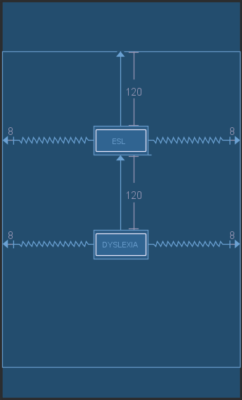

If this is pressed it will use the Dyslexia letter table for the letter scrambling.

If this is pressed it will use the ESL letter table for the letter scrambling.

Figure 33

## Class Diagram:

Below are my class designs, as derived from the working prototype using the Javadoc tool.

Detailed Class Breakdown

13/05/19 20:31

|  |  |
| --- | --- |
| Package Summary | |
| **com.example.meg.multiplechoicequiz** | |  | | --- | |  | |

Package com.example.meg.multiplechoicequiz

|  |  |
| --- | --- |
| Class Summary | |
| **DictionaryLoader** | |  | | --- | |  | |
| **DictRandAccIndex** | |  | | --- | |  | |
| **LetterData** | |  | | --- | |  | |
| **mainQuiz** | |  | | --- | |  | |
| **QuizWord** | |  | | --- | |  | |
| **SubstEntry** | |  | | --- | |  | |
| **SubstQuizWord** | |  | | --- | |  | |
| **SubstTable** | |  | | --- | |  | |
| **Utilities** | |  | | --- | |  | |

Class DictionaryLoader

**com.example.meg.multiplechoicequiz**

java.lang.Object

  com.example.meg.multiplechoicequiz.DictionaryLoader

public class DictionaryLoader

extends Object

|  |  |
| --- | --- |
| Field Summary | |
| private android.content.Context | **context** |
| private File | **dictDirectory** |
| private edu.mit.jwi.Dictionary | **instance** |
| private File | **targetDirectory** |
| private String | **zipFileName** |
| Constructor Summary | |
| **DictionaryLoader**(android.content.Context context)  Loads the dictionary with just context | |
| **DictionaryLoader**(android.content.Context context, String zipFileName)  Loads the dictionary with both context and file name | |
| **DictionaryLoader**(android.content.Context context, String zipFileName, String targetSubFolder)  Loads the dictionary with context, file name and the target sub folder | |
| **DictionaryLoader**(android.content.Context context, String zipFileName, String targetSubFolder, boolean externalStorage)  Loads the dictionary from the .zip file | |

|  |  |
| --- | --- |
| Method Summary | |
| edu.mit.jwi.IDictionary | **createInstance**()  creates the instance of IDictionary |
| boolean | **exists**()  Checks to see if the file exits |
| edu.mit.jwi.IDictionary | **getInstance**()  gets the IDictionary instance |
| void | **install**()  Installs the dictionary from the zip file stored in assets to the desired folder of private storage |

Field Detail

context

private android.content.Context context

zipFileName

private String zipFileName

targetDirectory

private File targetDirectory

dictDirectory

private File dictDirectory

instance

private edu.mit.jwi.Dictionary instance

Constructor Detail

DictionaryLoader

public DictionaryLoader(android.content.Context context,  
                        String zipFileName,  
                        String targetSubFolder,  
                        boolean externalStorage)

Loads the dictionary from the .zip file

Parameters:

context - gets context of the in activity class

zipFileName - passes the string file name to the class

targetSubFolder - passes the class the sub folders target location

externalStorage - whether or not a the external storage is available.

DictionaryLoader

public DictionaryLoader(android.content.Context context,  
                        String zipFileName,  
                        String targetSubFolder)

Loads the dictionary with context, file name and the target sub folder

Parameters:

context - gets context of the in activity class

zipFileName - passes the string file name to the class

targetSubFolder - passes the class the sub folders target location

DictionaryLoader

public DictionaryLoader(android.content.Context context,  
                        String zipFileName)

Loads the dictionary with both context and file name

Parameters:

context - context gets context of the in activity class

zipFileName - passes the string file name to the class

DictionaryLoader

public DictionaryLoader(android.content.Context context)

Loads the dictionary with just context

Parameters:

context - gets context of the in activity class

Method Detail

exists

public boolean exists()

Checks to see if the file exits

Returns:

the dictionary as a list which must be greater than 0.

install

public void install()  
             throws IOException

Installs the dictionary from the zip file stored in assets to the desired folder of private storage

Throws:

IOException

createInstance

public edu.mit.jwi.IDictionary createInstance()

creates the instance of IDictionary

Throws:

IOException

getInstance

public edu.mit.jwi.IDictionary getInstance()

gets the IDictionary instance

Returns:

the instance

Class DictRandAccIndex

**com.example.meg.multiplechoicequiz**

java.lang.Object

  com.example.meg.multiplechoicequiz.DictRandAccIndex

All Implemented Interfaces:

Serializable

public class DictRandAccIndex

extends Object

implements Serializable

|  |  |
| --- | --- |
| Field Summary | |
| private ArrayList<edu.mit.jwi.item.IIndexWordID> | **allWords** |
| private ArrayList<edu.mit.jwi.item.IIndexWordID> | **commonWords** |
| private edu.mit.jwi.IDictionary | **dict** |
| private static String | **FILENAME**  Sets the name of the file to dict.set |
| Constructor Summary | |
| |  | | --- | |  | | **DictRandAccIndex**(edu.mit.jwi.IDictionary dict)  Creates the empty indexes and then calls the helper function to populate them from the dictionary. |
| private | **DictRandAccIndex**(edu.mit.jwi.IDictionary dict, ObjectInputStream ois)  populates the indexes directly from an ObjectInputStream. |

|  |  |
| --- | --- |
| Method Summary | |
| edu.mit.jwi.item.IIndexWordID | **get**(int index)  This gets all words |
| edu.mit.jwi.item.IIndexWordID | **getCommon**(int index)  This gets the common word |
| int | **getCommonSize**()  Retrieves the common words size |
| int | **getSize**()  It will determined the size of the all words ArrayList |
| static DictRandAccIndex | **loadOrCreate**(android.content.ContextWrapper wrapper, edu.mit.jwi.IDictionary dict) |
| private void | **makeArrList**(edu.mit.jwi.item.POS pos)  makeArray first gets an iterator from WordNet for one of the word index lists in the WordNet dictionary (Nouns, Verbs etc.). |

Field Detail

allWords

private ArrayList<edu.mit.jwi.item.IIndexWordID> allWords

commonWords

private ArrayList<edu.mit.jwi.item.IIndexWordID> commonWords

dict

private edu.mit.jwi.IDictionary dict

FILENAME

private static final String FILENAME

Sets the name of the file to dict.set

Constructor Detail

DictRandAccIndex

public DictRandAccIndex(edu.mit.jwi.IDictionary dict)

Creates the empty indexes and then calls the helper function to populate them from the dictionary. It calls the helper four times, once for each POS. This constructor is used during start-up the first time the app is run after installation. Saving of the file is completed elsewhere.

Parameters:

dict - object of dictionary loader

DictRandAccIndex

private DictRandAccIndex(edu.mit.jwi.IDictionary dict,  
                         ObjectInputStream ois)  
                  throws ClassNotFoundException,  
                         IOException

populates the indexes directly from an ObjectInputStream. This is used during start-up on the second and successive times the app is run as part of the process of loading the indexes from the dict.ser file in private storage.

Parameters:

dict - object of dictionary loader

ois - this is the object for the deserialization

Throws:

ClassNotFoundException

IOException

Method Detail

getCommon

public edu.mit.jwi.item.IIndexWordID getCommon(int index)

This gets the common word

Parameters:

index - it the number of the word I want

Returns:

the index

get

public edu.mit.jwi.item.IIndexWordID get(int index)

This gets all words

Parameters:

index - is the number of the word I want

Returns:

the index

getCommonSize

public int getCommonSize()

Retrieves the common words size

Returns:

the common words size

getSize

public int getSize()

It will determined the size of the all words ArrayList

Returns:

all words size

makeArrList

private void makeArrList(edu.mit.jwi.item.POS pos)

makeArray first gets an iterator from WordNet for one of the word index lists in the WordNet dictionary (Nouns, Verbs etc.). It then steps through every index entry in that list using the iterator. The code then checks the word against a regular expression â€“ a regex is a way of checking whether a string matches a given pattern. In this case it looks to see if the word starts with a possibly capital letter ( [A-Za-z] ), followed by between 2 and 14 characters ( {2,14} ) that only contains lowercase letters ( [a-z] ) - so no spaces, punctuation or capitalized abbreviations. If the word matches, then it is added to the allWords array list. If it is a common word (getTagSenseCount() > 3), then it is added to the commonWords array list.

Parameters:

pos - is a part of speech, so defines the type of word.

loadOrCreate

public static DictRandAccIndex loadOrCreate(android.content.ContextWrapper wrapper,  
                                            edu.mit.jwi.IDictionary dict)

Parameters:

wrapper - is a object that can contain an activity i.e. access to private storage

dict - object of the dictionary

Returns:

the new similar word index (newSwi)

Class LetterData

**com.example.meg.multiplechoicequiz**

java.lang.Object

  com.example.meg.multiplechoicequiz.LetterData

public class LetterData

extends Object

|  |  |
| --- | --- |
| Field Summary | |
| static String[][] | **SIMILAR_SOUNDS**  This is a 2D array of strings which has the grouped similar sounding letter pairs which will be used for the letter scrambling. |
| Constructor Summary | |
| **LetterData**() | |

Field Detail

SIMILAR_SOUNDS

public static final String[][] SIMILAR_SOUNDS

This is a 2D array of strings which has the grouped similar sounding letter pairs which will be used for the letter scrambling.

Constructor Detail

LetterData

public LetterData()

Class mainQuiz

**com.example.meg.multiplechoicequiz**

java.lang.Object

  android.content.Context

      android.content.ContextWrapper

          android.view.ContextThemeWrapper

              android.app.Activity

                  android.support.v4.app.SupportActivity

                      android.support.v4.app.BaseFragmentActivityApi14

                          android.support.v4.app.BaseFragmentActivityApi16

                              android.support.v4.app.FragmentActivity

                                  android.support.v7.app.AppCompatActivity

                                      com.example.meg.multiplechoicequiz.mainQuiz

All Implemented Interfaces:

android.support.v7.app.ActionBarDrawerToggle.DelegateProvider, android.support.v4.app.ActivityCompat.OnRequestPermissionsResultCallback, android.support.v4.app.ActivityCompat.RequestPermissionsRequestCodeValidator, android.support.v7.app.AppCompatCallback, android.content.ComponentCallbacks, android.content.ComponentCallbacks2, android.view.KeyEvent.Callback, android.view.LayoutInflater.Factory, android.view.LayoutInflater.Factory2, android.arch.lifecycle.LifecycleOwner, android.support.v4.app.TaskStackBuilder.SupportParentable, android.view.View.OnCreateContextMenuListener, android.arch.lifecycle.ViewModelStoreOwner, android.view.Window.Callback

public class mainQuiz

extends android.support.v7.app.AppCompatActivity

|  |  |
| --- | --- |
| Nested classes/interfaces inherited from class android.support.v4.app.SupportActivity | |
| SupportActivity.ExtraData | |
| Field Summary | |
| private edu.mit.jwi.IDictionary | **dict** |
| private DictionaryLoader | **dictionaryLoader** |
| private DictRandAccIndex | **dictRandAccIndex** |
| private String | **mAnswer** |
| private android.widget.Button | **mButtonChoice1** |
| private android.widget.Button | **mButtonChoice2** |
| private android.widget.Button | **mButtonChoice3** |
| private android.widget.Button | **mButtonuserscore** |
| private android.widget.TextView | **mQuestionView** |
| private int | **mScore** |
| private android.widget.TextView | **mScoreView** |
| private int | **questionAsked** |
| private String | **questionText** |
| private QuizWord[] | **quizWords** |
| android.widget.Button | **sBtn** |

|  |
| --- |
| Fields inherited from class android.app.Activity |
| DEFAULT_KEYS_DIALER, DEFAULT_KEYS_DISABLE, DEFAULT_KEYS_SEARCH_GLOBAL, DEFAULT_KEYS_SEARCH_LOCAL, DEFAULT_KEYS_SHORTCUT, FOCUSED_STATE_SET, RESULT_CANCELED, RESULT_FIRST_USER, RESULT_OK |
| Fields inherited from class android.content.Context |
| ACCESSIBILITY_SERVICE, ACCOUNT_SERVICE, ACTIVITY_SERVICE, ALARM_SERVICE, APP_OPS_SERVICE, APPWIDGET_SERVICE, AUDIO_SERVICE, BATTERY_SERVICE, BIND_ABOVE_CLIENT, BIND_ADJUST_WITH_ACTIVITY, BIND_ALLOW_OOM_MANAGEMENT, BIND_AUTO_CREATE, BIND_DEBUG_UNBIND, BIND_EXTERNAL_SERVICE, BIND_IMPORTANT, BIND_NOT_FOREGROUND, BIND_WAIVE_PRIORITY, BLUETOOTH_SERVICE, CAMERA_SERVICE, CAPTIONING_SERVICE, CARRIER_CONFIG_SERVICE, CLIPBOARD_SERVICE, COMPANION_DEVICE_SERVICE, CONNECTIVITY_SERVICE, CONSUMER_IR_SERVICE, CONTEXT_IGNORE_SECURITY, CONTEXT_INCLUDE_CODE, CONTEXT_RESTRICTED, DEVICE_POLICY_SERVICE, DISPLAY_SERVICE, DOWNLOAD_SERVICE, DROPBOX_SERVICE, FINGERPRINT_SERVICE, HARDWARE_PROPERTIES_SERVICE, INPUT_METHOD_SERVICE, INPUT_SERVICE, JOB_SCHEDULER_SERVICE, KEYGUARD_SERVICE, LAUNCHER_APPS_SERVICE, LAYOUT_INFLATER_SERVICE, LOCATION_SERVICE, MEDIA_PROJECTION_SERVICE, MEDIA_ROUTER_SERVICE, MEDIA_SESSION_SERVICE, MIDI_SERVICE, MODE_APPEND, MODE_ENABLE_WRITE_AHEAD_LOGGING, MODE_MULTI_PROCESS, MODE_NO_LOCALIZED_COLLATORS, MODE_PRIVATE, MODE_WORLD_READABLE, MODE_WORLD_WRITEABLE, NETWORK_STATS_SERVICE, NFC_SERVICE, NOTIFICATION_SERVICE, NSD_SERVICE, POWER_SERVICE, PRINT_SERVICE, RECEIVER_VISIBLE_TO_INSTANT_APPS, RESTRICTIONS_SERVICE, SEARCH_SERVICE, SENSOR_SERVICE, SHORTCUT_SERVICE, STORAGE_SERVICE, STORAGE_STATS_SERVICE, SYSTEM_HEALTH_SERVICE, TELECOM_SERVICE, TELEPHONY_SERVICE, TELEPHONY_SUBSCRIPTION_SERVICE, TEXT_CLASSIFICATION_SERVICE, TEXT_SERVICES_MANAGER_SERVICE, TV_INPUT_SERVICE, UI_MODE_SERVICE, USAGE_STATS_SERVICE, USB_SERVICE, USER_SERVICE, VIBRATOR_SERVICE, WALLPAPER_SERVICE, WIFI_AWARE_SERVICE, WIFI_P2P_SERVICE, WIFI_SERVICE, WINDOW_SERVICE |

|  |
| --- |
| Fields inherited from interface android.content.ComponentCallbacks2 |
| TRIM_MEMORY_BACKGROUND, TRIM_MEMORY_COMPLETE, TRIM_MEMORY_MODERATE, TRIM_MEMORY_RUNNING_CRITICAL, TRIM_MEMORY_RUNNING_LOW, TRIM_MEMORY_RUNNING_MODERATE, TRIM_MEMORY_UI_HIDDEN |
| Constructor Summary |
| **mainQuiz**() |

|  |  |
| --- | --- |
| Method Summary | |
| private void | **chooseQuestion**()  Choose the next question ready for the user Increments the number of questions asked |
| private DictionaryLoader | **getDictionaryLoader**()  gets the dictionary loader |
| protected void | **onCreate**(android.os.Bundle savedInstanceState)  this save the state of the application in a bundle (typically non-persistent, dynamic data in onSaveInstanceState), it can be passed back to onCreate if the activity needs to be recreated (e.g., orientation change) so that it don't lose this prior information. |
| private void | **setupVars**()  Loads a dictionary, checks for the files and if it is exists then it loads to the phone |
| private void | **updateQuestion**()  This updates the question required and sets the text on the buttons and in the text edit accordingly. |
| private void | **updateScore**()  This updates the score and set the display to the score so the user can see it. |
| private void | **UsersScore**() |
| Methods inherited from class android.support.v7.app.AppCompatActivity | |
| addContentView, closeOptionsMenu, dispatchKeyEvent, findViewById, getDelegate, getDrawerToggleDelegate, getMenuInflater, getResources, getSupportActionBar, getSupportParentActivityIntent, invalidateOptionsMenu, onConfigurationChanged, onContentChanged, onCreateSupportNavigateUpTaskStack, onDestroy, onKeyDown, onMenuItemSelected, onMenuOpened, onPanelClosed, onPostCreate, onPostResume, onPrepareSupportNavigateUpTaskStack, onSaveInstanceState, onStart, onStop, onSupportActionModeFinished, onSupportActionModeStarted, onSupportContentChanged, onSupportNavigateUp, onTitleChanged, onWindowStartingSupportActionMode, openOptionsMenu, setContentView, setContentView, setContentView, setSupportActionBar, setSupportProgress, setSupportProgressBarIndeterminate, setSupportProgressBarIndeterminateVisibility, setSupportProgressBarVisibility, setTheme, startSupportActionMode, supportInvalidateOptionsMenu, supportNavigateUpTo, supportRequestWindowFeature, supportShouldUpRecreateTask | |

|  |
| --- |
| Methods inherited from class android.support.v4.app.FragmentActivity |
| dump, getLastCustomNonConfigurationInstance, getLifecycle, getSupportFragmentManager, getSupportLoaderManager, getViewModelStore, onActivityResult, onAttachFragment, onBackPressed, onCreatePanelMenu, onLowMemory, onMultiWindowModeChanged, onNewIntent, onPause, onPictureInPictureModeChanged, onPrepareOptionsPanel, onPreparePanel, onRequestPermissionsResult, onResume, onResumeFragments, onRetainCustomNonConfigurationInstance, onRetainNonConfigurationInstance, onStateNotSaved, setEnterSharedElementCallback, setExitSharedElementCallback, startActivityForResult, startActivityFromFragment, startActivityFromFragment, startIntentSenderFromFragment, supportFinishAfterTransition, supportPostponeEnterTransition, supportStartPostponedEnterTransition, validateRequestPermissionsRequestCode |
| Methods inherited from class android.support.v4.app.BaseFragmentActivityApi16 |
| startActivityForResult, startIntentSenderForResult |

|  |
| --- |
| Methods inherited from class android.support.v4.app.BaseFragmentActivityApi14 |
| onCreateView, onCreateView, startIntentSenderForResult |
| Methods inherited from class android.support.v4.app.SupportActivity |
| getExtraData, putExtraData |

|  |
| --- |
| Methods inherited from class android.app.Activity |
| attachBaseContext, closeContextMenu, createPendingResult, dismissDialog, dismissKeyboardShortcutsHelper, dispatchGenericMotionEvent, dispatchKeyShortcutEvent, dispatchPopulateAccessibilityEvent, dispatchTouchEvent, dispatchTrackballEvent, enterPictureInPictureMode, enterPictureInPictureMode, finish, finishActivity, finishActivityFromChild, finishAffinity, finishAfterTransition, finishAndRemoveTask, finishFromChild, getActionBar, getApplication, getCallingActivity, getCallingPackage, getChangingConfigurations, getComponentName, getContentScene, getContentTransitionManager, getCurrentFocus, getFragmentManager, getIntent, getLastNonConfigurationInstance, getLayoutInflater, getLoaderManager, getLocalClassName, getMaxNumPictureInPictureActions, getMediaController, getParent, getParentActivityIntent, getPreferences, getReferrer, getRequestedOrientation, getSearchEvent, getSystemService, getTaskId, getTitle, getTitleColor, getVoiceInteractor, getVolumeControlStream, getWindow, getWindowManager, hasWindowFocus, isActivityTransitionRunning, isChangingConfigurations, isChild, isDestroyed, isFinishing, isImmersive, isInMultiWindowMode, isInPictureInPictureMode, isLocalVoiceInteractionSupported, isTaskRoot, isVoiceInteraction, isVoiceInteractionRoot, managedQuery, moveTaskToBack, navigateUpTo, navigateUpToFromChild, onActionModeFinished, onActionModeStarted, onActivityReenter, onApplyThemeResource, onAttachedToWindow, onAttachFragment, onChildTitleChanged, onContextItemSelected, onContextMenuClosed, onCreate, onCreateContextMenu, onCreateDescription, onCreateDialog, onCreateDialog, onCreateNavigateUpTaskStack, onCreateOptionsMenu, onCreatePanelView, onCreateThumbnail, onDetachedFromWindow, onEnterAnimationComplete, onGenericMotionEvent, onKeyLongPress, onKeyMultiple, onKeyShortcut, onKeyUp, onLocalVoiceInteractionStarted, onLocalVoiceInteractionStopped, onMultiWindowModeChanged, onNavigateUp, onNavigateUpFromChild, onOptionsItemSelected, onOptionsMenuClosed, onPictureInPictureModeChanged, onPostCreate, onPrepareDialog, onPrepareDialog, onPrepareNavigateUpTaskStack, onPrepareOptionsMenu, onProvideAssistContent, onProvideAssistData, onProvideKeyboardShortcuts, onProvideReferrer, onRestart, onRestoreInstanceState, onRestoreInstanceState, onSaveInstanceState, onSearchRequested, onSearchRequested, onTouchEvent, onTrackballEvent, onTrimMemory, onUserInteraction, onUserLeaveHint, onVisibleBehindCanceled, onWindowAttributesChanged, onWindowFocusChanged, onWindowStartingActionMode, onWindowStartingActionMode, openContextMenu, overridePendingTransition, postponeEnterTransition, recreate, registerForContextMenu, releaseInstance, removeDialog, reportFullyDrawn, requestDragAndDropPermissions, requestPermissions, requestShowKeyboardShortcuts, requestVisibleBehind, requestWindowFeature, runOnUiThread, setActionBar, setContentTransitionManager, setDefaultKeyMode, setEnterSharedElementCallback, setExitSharedElementCallback, setFeatureDrawable, setFeatureDrawableAlpha, setFeatureDrawableResource, setFeatureDrawableUri, setFinishOnTouchOutside, setImmersive, setIntent, setMediaController, setPictureInPictureParams, setProgress, setProgressBarIndeterminate, setProgressBarIndeterminateVisibility, setProgressBarVisibility, setRequestedOrientation, setResult, setResult, setSecondaryProgress, setShowWhenLocked, setTaskDescription, setTitle, setTitle, setTitleColor, setTurnScreenOn, setVisible, setVolumeControlStream, setVrModeEnabled, shouldShowRequestPermissionRationale, shouldUpRecreateTask, showAssist, showDialog, showDialog, showLockTaskEscapeMessage, startActionMode, startActionMode, startActivities, startActivities, startActivity, startActivity, startActivityFromChild, startActivityFromChild, startActivityFromFragment, startActivityFromFragment, startActivityIfNeeded, startActivityIfNeeded, startIntentSender, startIntentSender, startIntentSenderFromChild, startIntentSenderFromChild, startLocalVoiceInteraction, startLockTask, startManagingCursor, startNextMatchingActivity, startNextMatchingActivity, startPostponedEnterTransition, startSearch, stopLocalVoiceInteraction, stopLockTask, stopManagingCursor, takeKeyEvents, triggerSearch, unregisterForContextMenu |
| Methods inherited from class android.view.ContextThemeWrapper |
| applyOverrideConfiguration, getAssets, getTheme |

|  |
| --- |
| Methods inherited from class android.content.ContextWrapper |
| bindService, checkCallingOrSelfPermission, checkCallingOrSelfUriPermission, checkCallingPermission, checkCallingUriPermission, checkPermission, checkSelfPermission, checkUriPermission, checkUriPermission, clearWallpaper, createConfigurationContext, createContextForSplit, createDeviceProtectedStorageContext, createDisplayContext, createPackageContext, databaseList, deleteDatabase, deleteFile, deleteSharedPreferences, enforceCallingOrSelfPermission, enforceCallingOrSelfUriPermission, enforceCallingPermission, enforceCallingUriPermission, enforcePermission, enforceUriPermission, enforceUriPermission, fileList, getApplicationContext, getApplicationInfo, getBaseContext, getCacheDir, getClassLoader, getCodeCacheDir, getContentResolver, getDatabasePath, getDataDir, getDir, getExternalCacheDir, getExternalCacheDirs, getExternalFilesDir, getExternalFilesDirs, getExternalMediaDirs, getFilesDir, getFileStreamPath, getMainLooper, getNoBackupFilesDir, getObbDir, getObbDirs, getPackageCodePath, getPackageManager, getPackageName, getPackageResourcePath, getSharedPreferences, getSystemServiceName, getWallpaper, getWallpaperDesiredMinimumHeight, getWallpaperDesiredMinimumWidth, grantUriPermission, isDeviceProtectedStorage, isRestricted, moveDatabaseFrom, moveSharedPreferencesFrom, openFileInput, openFileOutput, openOrCreateDatabase, openOrCreateDatabase, peekWallpaper, registerReceiver, registerReceiver, registerReceiver, registerReceiver, removeStickyBroadcast, removeStickyBroadcastAsUser, revokeUriPermission, revokeUriPermission, sendBroadcast, sendBroadcast, sendBroadcastAsUser, sendBroadcastAsUser, sendOrderedBroadcast, sendOrderedBroadcast, sendOrderedBroadcastAsUser, sendStickyBroadcast, sendStickyBroadcastAsUser, sendStickyOrderedBroadcast, sendStickyOrderedBroadcastAsUser, setWallpaper, setWallpaper, startForegroundService, startInstrumentation, startService, stopService, unbindService, unregisterReceiver |
| Methods inherited from class android.content.Context |
| getColor, getColorStateList, getDrawable, getString, getString, getSystemService, getText, obtainStyledAttributes, obtainStyledAttributes, obtainStyledAttributes, obtainStyledAttributes, registerComponentCallbacks, unregisterComponentCallbacks |

|  |
| --- |
| Methods inherited from interface android.view.Window.Callback |
| onPointerCaptureChanged |

Field Detail

dictionaryLoader

private DictionaryLoader dictionaryLoader

dict

private edu.mit.jwi.IDictionary dict

dictRandAccIndex

private DictRandAccIndex dictRandAccIndex

questionText

private String questionText

quizWords

private QuizWord[] quizWords

mScoreView

private android.widget.TextView mScoreView

mQuestionView

private android.widget.TextView mQuestionView

mButtonChoice1

private android.widget.Button mButtonChoice1

mButtonChoice2

private android.widget.Button mButtonChoice2

mButtonChoice3

private android.widget.Button mButtonChoice3

mButtonuserscore

private android.widget.Button mButtonuserscore

sBtn

android.widget.Button sBtn

mAnswer

private String mAnswer

mScore

private int mScore

questionAsked

private int questionAsked

Constructor Detail

mainQuiz

public mainQuiz()

Method Detail

getDictionaryLoader

private [DictionaryLoader](#a16" \o "class in com.example.meg.multiplechoicequiz) getDictionaryLoader()

gets the dictionary loader

Returns:

the dictionary loader

onCreate

protected void onCreate(android.os.Bundle savedInstanceState)

this save the state of the application in a bundle (typically non-persistent, dynamic data in onSaveInstanceState), it can be passed back to onCreate if the activity needs to be recreated (e.g., orientation change) so that it don't lose this prior information.

Overrides:

onCreate in class android.support.v7.app.AppCompatActivity

Parameters:

savedInstanceState - is the bundle name.

setupVars

private void setupVars()

Loads a dictionary, checks for the files and if it is exists then it loads to the phone

chooseQuestion

private void chooseQuestion()

Choose the next question ready for the user Increments the number of questions asked

updateQuestion

private void updateQuestion()

This updates the question required and sets the text on the buttons and in the text edit accordingly.

updateScore

private void updateScore()

This updates the score and set the display to the score so the user can see it.

UsersScore

private void UsersScore()

Class QuizWord

**com.example.meg.multiplechoicequiz**

java.lang.Object

  com.example.meg.multiplechoicequiz.QuizWord

Direct Known Subclasses:

SubstQuizWord

abstract public class QuizWord

extends Object

|  |  |
| --- | --- |
| Field Summary | |
| protected String | **text** |
| Constructor Summary | |
| **QuizWord**(String text)  Sets the instance text quizWord text | |

|  |  |
| --- | --- |
| Method Summary | |
| String | **getText**()  Gets the text |
| abstract QuizWord | **makeNewWord**() |
| abstract QuizWord[] | **makeNewWords**(int count) |
| void | **run**() |

Field Detail

text

protected String text

Constructor Detail

QuizWord

public QuizWord(String text)

Sets the instance text quizWord text

Parameters:

text - points to the current class instance

Method Detail

makeNewWord

public abstract [QuizWord](#a63" \o "class in com.example.meg.multiplechoicequiz) makeNewWord()

makeNewWords

public abstract [QuizWord](#a63" \o "class in com.example.meg.multiplechoicequiz)[] makeNewWords(int count)

getText

public String getText()

Gets the text

Returns:

returns a string

run

public void run()

Class SubstEntry

**com.example.meg.multiplechoicequiz**

java.lang.Object

  com.example.meg.multiplechoicequiz.SubstEntry

public class SubstEntry

extends Object

|  |  |
| --- | --- |
| Field Summary | |
| private String[] | **data** |
| private int | **replaceEntry** |
| private int | **replaceLength** |
| Constructor Summary | |
| **SubstEntry**(String[] data, int replaceEntry)  Creates instances for this class | |

|  |  |
| --- | --- |
| Method Summary | |
| int | **getCount**()  Counts the data length. |
| String | **getItem**(int index)  Gets the data index |
| int | **getReplaceEntry**()  Gets the replacment entry integer |
| int | **getReplaceLength**()  Gets the replacement length |

Field Detail

data

private String[] data

replaceLength

private int replaceLength

replaceEntry

private int replaceEntry

Constructor Detail

SubstEntry

public SubstEntry(String[] data,  
                  int replaceEntry)

Creates instances for this class

Parameters:

data - is the array of words (data)

replaceEntry - this is the index for the next entry.

Method Detail

getReplaceEntry

public int getReplaceEntry()

Gets the replacment entry integer

Returns:

an integer

getReplaceLength

public int getReplaceLength()

Gets the replacement length

Returns:

integer

getCount

public int getCount()

Counts the data length.

Returns:

text array data

getItem

public String getItem(int index)

Gets the data index

Parameters:

index - is the amount of data needed

Returns:

data index

Class SubstQuizWord

**com.example.meg.multiplechoicequiz**

java.lang.Object

com.example.meg.multiplechoicequiz.QuizWord

      com.example.meg.multiplechoicequiz.SubstQuizWord

public class SubstQuizWord

extends QuizWord

|  |  |
| --- | --- |
| Field Summary | |
| SubstTable | **table** |
| Fields inherited from class com.example.meg.multiplechoicequiz.**QuizWord** | |
| text | |

|  |  |
| --- | --- |
| Constructor Summary | |
| **SubstQuizWord**(String text, SubstTable table)  Links the table of values of the pairs of letters that need scrambling. | |
| Method Summary | |
| QuizWord | **makeNewWord**()  This creates the new word It also creates the scrambled words using the max and min length and changes the number of swaps dependent upon the number of letters in the word |
| QuizWord[] | **makeNewWords**(int count)  makes a new word and then finds the next word using the random function |

|  |
| --- |
| Methods inherited from class com.example.meg.multiplechoicequiz.**QuizWord** |
| getText, run |

Field Detail

table

SubstTable table

Constructor Detail

SubstQuizWord

public SubstQuizWord(String text,  
                     [SubstTable](#a86" \o "class in com.example.meg.multiplechoicequiz) table)

Links the table of values of the pairs of letters that need scrambling.

Parameters:

text - String passed into the class

table - passes the table through to the class

Method Detail

makeNewWord

public [QuizWord](#a63" \o "class in com.example.meg.multiplechoicequiz) makeNewWord()

This creates the new word It also creates the scrambled words using the max and min length and changes the number of swaps dependent upon the number of letters in the word

Overrides:

makeNewWord in class QuizWord

Returns:

null if no word is found

makeNewWords

public [QuizWord](#a63" \o "class in com.example.meg.multiplechoicequiz)[] makeNewWords(int count)

makes a new word and then finds the next word using the random function

Overrides:

makeNewWords in class QuizWord

Parameters:

count - integer that keeps track of the entry

Returns:

the variable returnValue

Class SubstTable

**com.example.meg.multiplechoicequiz**

java.lang.Object

  com.example.meg.multiplechoicequiz.SubstTable

public class SubstTable

extends Object

|  |  |
| --- | --- |
| Field Summary | |
| private HashMap<String,SubstEntry> | **hashMap** |
| private int | **maxReplaceLength** |
| private int | **minReplaceLength** |
| static SubstTable | **similarSoundsTable**  Sets up the new table with the data from the Similar sounds data |
| Constructor Summary | |
| |  | | --- | |  | | **SubstTable**(String[][] letterData)  This is the letter scrambler class |

|  |  |
| --- | --- |
| Method Summary | |
| SubstEntry | **getEntry**(String partWord) |
| int | **getMaxReplaceLength**()  gets the maximum length of the words that can be swapped |
| int | **getMinReplaceLength**()  gets the minimum length of the words that can be swapped |

Field Detail

similarSoundsTable

public static final SubstTable similarSoundsTable

Sets up the new table with the data from the Similar sounds data

hashMap

private HashMap<String,SubstEntry> hashMap

minReplaceLength

private int minReplaceLength

maxReplaceLength

private int maxReplaceLength

Constructor Detail

SubstTable

SubstTable(String[][] letterData)

This is the letter scrambler class

Parameters:

letterData - An array of letters that can be replaced.

Method Detail

getEntry

public [SubstEntry](#a72" \o "class in com.example.meg.multiplechoicequiz) getEntry(String partWord)

Parameters:

partWord - this is the smaller sections of the words

Returns:

the hashmap part of the word

getMinReplaceLength

public int getMinReplaceLength()

gets the minimum length of the words that can be swapped

Returns:

minReplaceLength

getMaxReplaceLength

public int getMaxReplaceLength()

gets the maximum length of the words that can be swapped

Returns:

maxReplacedLength

Class Utilities

**com.example.meg.multiplechoicequiz**

java.lang.Object

  com.example.meg.multiplechoicequiz.Utilities

public class Utilities

extends Object

|  |  |
| --- | --- |
| Constructor Summary | |
| **Utilities**() | |
| Method Summary | |
| static File | **getPrivateFile**(android.content.ContextWrapper wrapper, String fname) |
| static boolean | **privateFileExists**(android.content.ContextWrapper wrapper, String fname) |

Constructor Detail

Utilities

public Utilities()

Method Detail

privateFileExists

public static boolean privateFileExists(android.content.ContextWrapper wrapper,  
                                        String fname)

getPrivateFile

public static File getPrivateFile(android.content.ContextWrapper wrapper,  
                                  String fname)

Parameters:

wrapper - is a context wrapper for the cactivity

fname - the String file name

Returns:

the absolute path on the filesystem where a file created with openFileOutput(String, int) is stored.

Java API documentation generated with [DocFlex/Doclet](http://www.filigris.com/products/docflex_javadoc/#docflex-doclet) v1.6.1

DocFlex/Doclet is both a multi-format Javadoc doclet and a free edition of [DocFlex/Javadoc](http://www.filigris.com/products/docflex_javadoc/). If you need to customize your Javadoc without writing a full-blown doclet from scratch, DocFlex/Javadoc may be the only tool able to help you! Find out more at [www.docflex.com](http://www.docflex.com/)

### Detailed Class Breakdown:



### Test Plan:

|  |  |  |  |  |
| --- | --- | --- | --- | --- |
| Test Num: | What’s been tested? | Data entered. | Expected outcome. | Actual outcome. |
|  | The quiz app opens | N/A | The application will open on the Samsung S9 |  |
|  | A definition of a word is loaded at the top of the screen. | N/A | A definition of a word will be displayed at the top of the screen, if the answer is in the definition then the word will be replaced with asterisk |  |
|  | Every definition that is loaded at the top of the screen must be different. | N/A | No data is entered however there should be no two definitions the same within close proximity. |  |
|  | Button one, two and three can be incorrect | Button one is pressed and is incorrect | If the button is pressed a toast message says incorrect. However, this can take while as the answers appear in a random order. |  |
|  | Button two is pressed and is incorrect |  |
|  | Button three is pressed and is incorrect |  |
|  | Button one, two and three can be correct | Button one is pressed and is correct | If the button is pressed a toast message says correct. However, this can take while as the answers appear in a random order. |  |
|  | Button one is pressed and is correct |  |
|  | Button one is pressed and is correct |  |
|  | The score increments by one | The button with the correct answer is pressed | The score will increment by 1 in the top right corner. |  |
|  | Score sheet button | The score button is pressed | than the user is taken to a new sheet that has a list of the most recent scores on the quiz. |  |
|  | The correct toast messages appear | Answer buttons | If the correct answer is pressed then a small message saying correct will appear or if the wrong answer is selected then incorrect will appear. |  |
|  | The correct word matches the definition | N/A | The correct word should match the definition |  |
|  | There are two scrambled options | N/A | Two out of the three buttons will have a scrambled option. |  |
|  | The home screen will have two options that must be given | ESL button is pressed | If ESL button is pressed, then the quiz will use the ESL letter jumbling array whereas if the dyslexia button is pressed it uses the Dyslexia array for jumbling the letters. |  |
|  | Dyslexia button is pressed |  |

## Implementation:

### The Quiz:

Due to timing issues I have chosen to use the letter jumbling/ scrambling as it is the faster algorithm to implement as I had already done similar code in another project, however it was in a Java syntax, so I will need to change this to the correct syntax to work with Android studio. However, to begin creating the quiz, I started by creating a dictionary of words, but in order to make this large enough that the user would not get bored and for timings I have decided to use a pre-made library of words. After some research and a suggestion from my computer science teacher I have chosen to use wordnet which is a large lexical database of English. Nouns, verbs, adjectives and adverbs are grouped into sets of cognitive synonyms (synsets), each expressing a distinct concept[2].

In order to use the wordnet software I had to import the library into the android studio which caused some issues while trying to implement together, this was as a result of having difficulties adding the Wordnet support to the app. To start I needed to add the Java Wordnet Interface (JWI) libraries. With help from my teacher I found that the best way to do this is was to add adding two things to the Gradle configuration, as Gradle is the build system Android Studio uses to build its apps. To begin I had to make sure I referenced the correct online repository for the latest version of JWI (2.4.0), to do this I had to add to the project repositories as seen in figure 34, the line surrounded with the red box, after which I resynced the project to ensure there was no issues. Then I needed to add to the dependencies of this modular project see figure 35, my additions are surrounded with a red box.

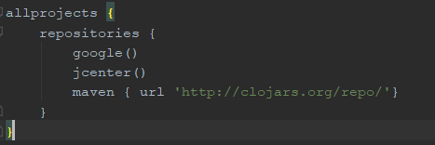

Figure 34

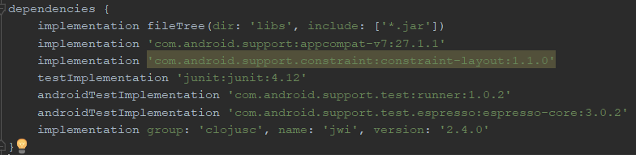

Figure 35

After I had completed this I did yet another project built and sync and everything came up with no issues, however, the process of adding the JWI libraries was more time consuming than I had initially believed it would be. After getting the project to successfully sync and build I needed to create an assets folder, which is storing the dictionary files. In order to get the file small enough to be suitable for storing within a mobile app I was required to store this as a .zip file. As a result, I have one file called “dict.zip” which contains all of the other Wordnet files.



Figure 36

After I had sorted the assets folder I needed to create a loader class. Android stores files in its own very specific folder structure. In many cases the normal IO functions do not work or work differently. Therefore, to enable me to use the normal IO functions within the JWI WordNet library, I need the data to be stored in internal private storage. However, for the data files to be distributed with the packaged app, they have to be stored as assets. These cannot be accessed via the normal IO functions, they have their own special functions. To get around this, I stored the dictionary in a zip file in the assets folder. Then provide a class which, when the app is run for the first time, extracts the zip file into private storage

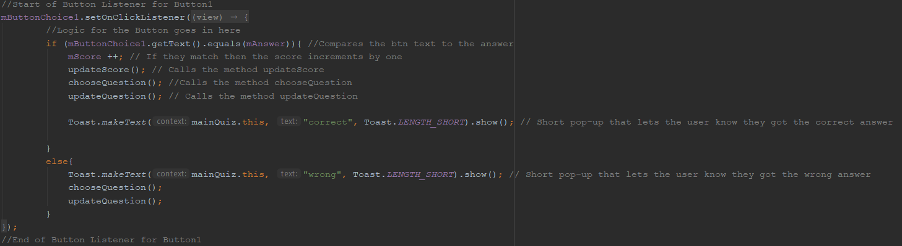

The above image shows the code that I have used for the buttons which the user will see the possible options for the answer to given definition, the code was repeated three times once for each of the buttons. Most of this code calls other functions which changes the possible outputs on the buttons. As it was easier to compare the button text to the correct answer rather than having a user enter the answer as lexical comparison is more intricate to program and currently out of my coding skills. Furthermore, I wanted the users to learn how to recognise different letter patterns and specifically for those who struggle with dyslexia to learn how to identify letters that look similar. As a result, this was an easier section to code.

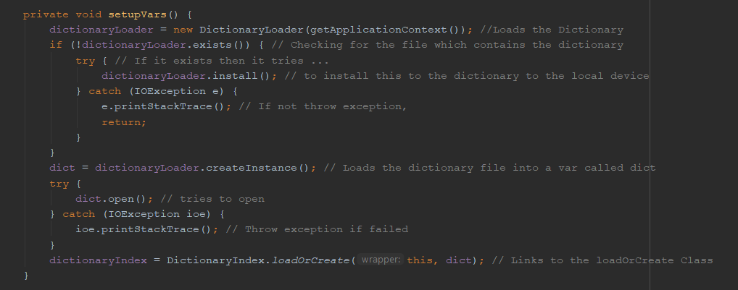

The function setupVars is what helps load the dictionary from the zip file into private storage and allow for the access to the file. In order not to clutter the users’ phone it uses a check to see if the file is already been stored in the private storage, this is because the user will not have access to the file however it doesn’t need to be downloaded more than once as it is a large file, furthermore, this would use storage on the users’ phone that would then be wasted.

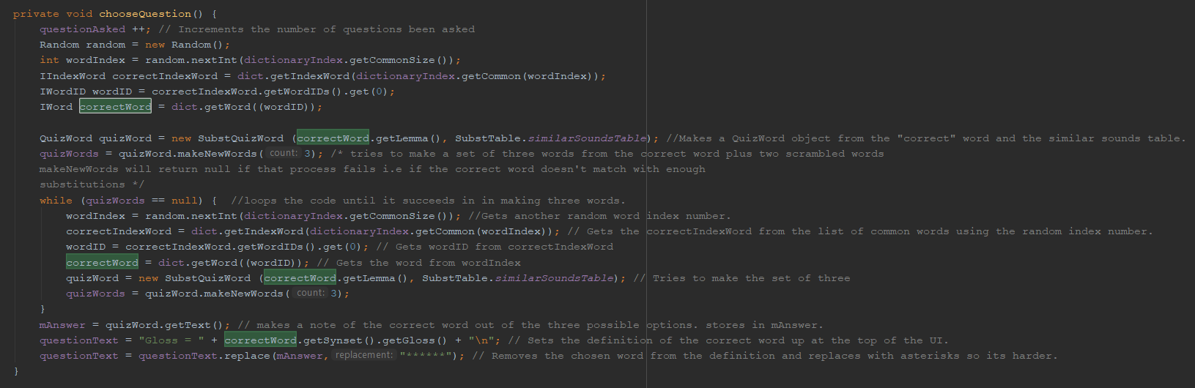

chooseQuestion() is used to make an object (QuizWord) from the “correct” word and the similar sounds table. Then it will make a set of three words from the correct word plus two mangled ones using the letter jumbling algorithm which it keep trying until it has succeeded making three words. Then it continues to by fetching a new “correct” word from the dictionary – which is a repeat of earlier in the code involving a lot of fetching different values for the variables. Which finally finishes when there is three words and the correct one is noted in mAnswer.

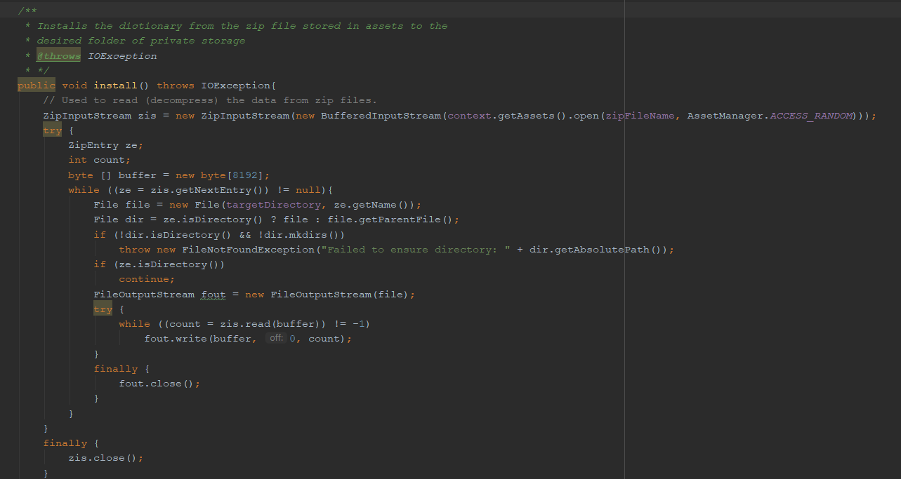

When the application is placed on the phone, all the files for the app come in a compressed in one archive file called an APK. This includes the WordNet dictionary files, which are stored as an asset. This code seen in the above screenshot extracts the files from the assets area of the APK to private storage on the phone, so you can use them without needing to redownload each time the application runs. 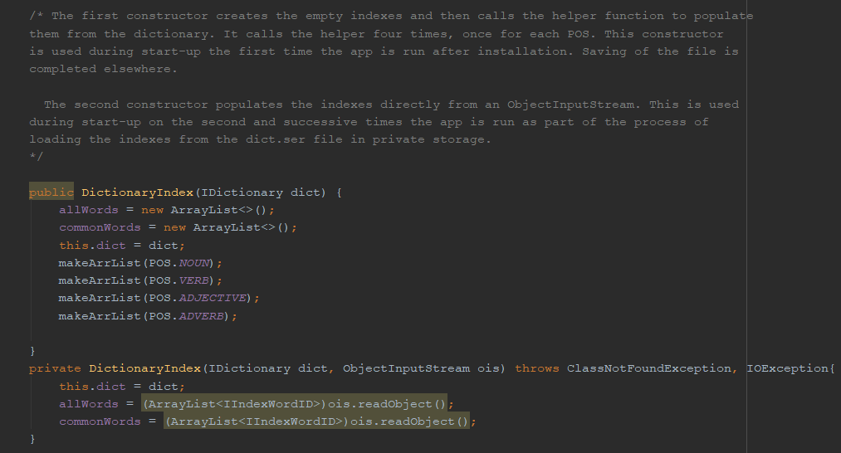

The above code shows the object of the class which contains two indexes, implemented using ArrayLists: allWords and commonWords. The first index stores every word in the dictionary that meet certain criteria as described later in this document. The second stores just the “common” subset of those words. The commonWords index allows me to choose a correct answer words and meanings that the user has some chance of understanding or recognising. The allWords index allows for the confusion that the word with ones that the user may never have heard of.  The first constructor creates the empty indexes and then calls the helper function to populate them from the dictionary. It calls the helper four times, once for each POS. This constructor is used during start-up the first time the app is run after installation. This takes a while so the saving of the result to file is done elsewhere in the code. The second constructor populates the indexes directly from an ObjectInputStream up on the second and successive times the app is run as part of the process of loading the indexes from the dict.ser file in private storage. The helper function (makeArrList) first gets an iterator (fancy name for an object that allows you to get elements one at a time from a sequence such as a list) from WordNet for one of the word index lists in the WordNet dictionary (Nouns, Verbs etc.). It then steps through every index entry in that list using the iterator. The code then checks the word against a regular expression – a regex is a way of checking whether a string matches a given pattern. In this case it looks to see if the word starts with a possibly capital letter ( [A-Za-z] ), followed by between 2 and 14 characters ( {2,14} ) that only contains lowercase letters ( [a-z] ) - so no spaces, punctuation or capitalized abbreviations. If the word matches, then it is added to the allWords array list. If it is a common word (getTagSenseCount() > 3), then it is added to the commonWords array list.

static public DictionaryIndex loadOrCreate(ContextWrapper wrapper, IDictionary dict){  
 DictionaryIndex newSwi = null;  
 if (Utilities.*privateFileExists*(wrapper, *FILENAME*)){  
 File file = Utilities.*getPrivateFile*(wrapper,*FILENAME*);  
 try  
 {  
 // Reading the object from a file  
 FileInputStream fis = new FileInputStream(file);  
 ObjectInputStream in = new ObjectInputStream(fis);  
  
 // Method for deserialization of object  
 newSwi = new DictionaryIndex(dict, in);  
  
 in.close();  
 fis.close();  
 }  
 catch(IOException ex)  
 {  
 ex.printStackTrace();  
 Toast.*makeText*(wrapper, ex.getMessage(), Toast.*LENGTH_SHORT*).show();  
 }  
 catch(ClassNotFoundException ex){  
 ex.printStackTrace();  
 Toast.*makeText*(wrapper, ex.getMessage(), Toast.*LENGTH_SHORT*).show();  
 }  
  
 }  
 else {  
 newSwi = new DictionaryIndex(dict);  
 File = Utilities.*getPrivateFile*(wrapper,*FILENAME*);  
 try  
 {  
 //Saving of object in a file  
 FileOutputStream fos = new FileOutputStream(file);  
 ObjectOutputStream out = new ObjectOutputStream(fos);  
  
 // Method for serialization of object  
 out.writeObject(newSwi.allWords);  
 out.writeObject(newSwi.commonWords);  
  
 out.close();  
 fos.close();  
   
 }  
 catch(IOException ex) {  
 ex.printStackTrace();  
 Toast.*makeText*(wrapper, ex.getMessage(), Toast.*LENGTH_SHORT*).show();  
 }  
 }  
 return newSwi;  
 }  
}

For the code seen in the above screenshot I have used the process if serial and deserialization. Serialization is a process of converting an object into a sequence of bytes which can be persisted to a disk or database or can be sent through streams. The reverse process of creating object from sequence of bytes is called deserialization. In order to show this procedure, I have used a diagram as seen below. However, this is only the saving/ opening of the file the first part of this program has been discussed on page 34.

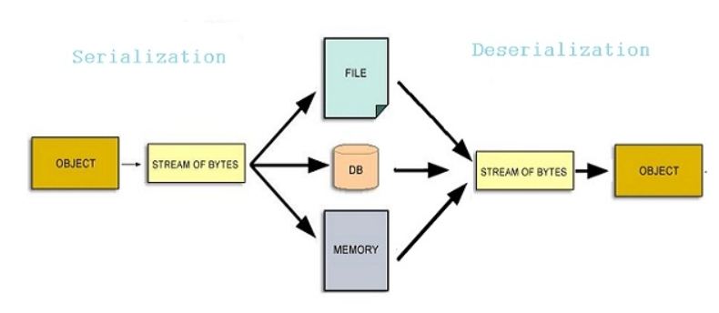

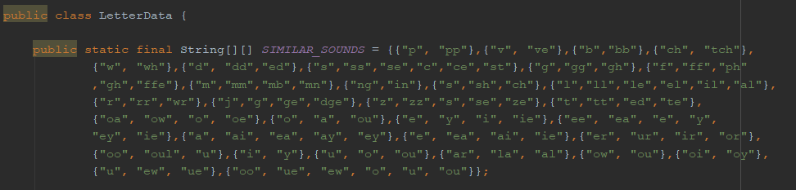

The above screenshot is the array that shows the groupings of the possible letters that can be swapped, I have grouped these based upon phonetic sounds (the English Phonetic Code). When swapping the letters in the correctWord for the other options it will only use the options in its arrays.

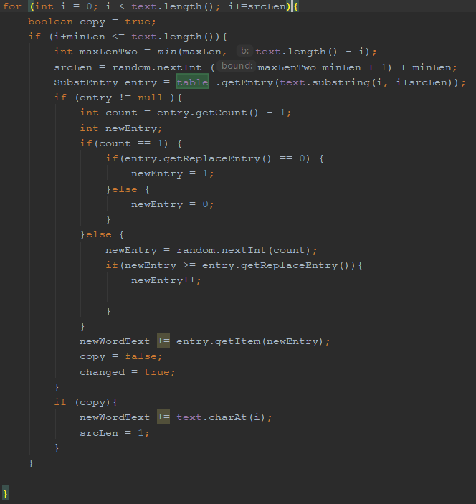

The above screenshot shows the code which allows for the random swapping of the letters. It checks that there is enough letters in the word to make the minimum swap. Furthermore, it checks that it completes a number of swaps so that more than one swap per word is completed. The code also makes sure that the program doesn’t end up creating duplicate words. Before, working on the user-friendly aspects of the quiz such as the option to pick the quiz option from the main screen , I chose to build and run the program to see that the swapping of the letters and the glossary etc worked. After I had run the code I spoke to the stakeholders to ensure that they were happy with the layout I needed to add an additional button so that the user can stop the code as currently it loops infinitely. As a result, the new layout is shown below.

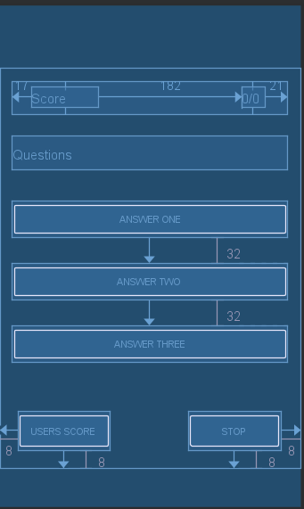 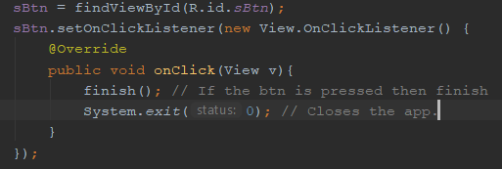

As can be seen I have added a button that will terminate the code if pressed. This code I added to this button is screenshotted above. Before continuing on I held meetings with my stakeholder groups all of whom agreed that the layout way fine, however suggested that for a later version that I should work on the letter jumbling as some of the possible options were so jumbled it made it obvious which was the wrong word. All said that they had fun playing, although stakeholders 2 and 3 suggest adding a league table to the quiz at a later date as a way of adding a competitive edge.

## Testing:

|  |  |  |  |  |  |
| --- | --- | --- | --- | --- | --- |
| Test Num: | What’s been tested? | Data entered. | Expected outcome. | Actual outcome. | Rectifications |
|  | The quiz app opens | N/A | The application will open on the Samsung S9 | As expected *(see table one)* | N/A |
|  | A definition of a word is loaded at the top of the screen. | N/A | A definition of a word will be displayed at the top of the screen, if the answer is in the definition then the word will be replaced with asterisk | As expected *(See table one)* | N/A |
|  | Every definition that is loaded at the top of the screen must be different. | N/A | No data is entered however there should be no two definitions the same within close proximity. | As expected *(See table one)* | N/A |
|  | Button one, two and three can be incorrect | Button one is pressed and is incorrect | If the button is pressed a toast message says incorrect. However, this can take while as the answers appear in a random order. | As expected *(See table two)* |  |
|  | Button two is pressed and is incorrect | As expected *(See table two)* |  |
|  | Button three is pressed and is incorrect | As expected *(See table two)* |  |
|  | Button one, two and three can be correct | Button one is pressed and is correct | If the button is pressed a toast message says correct. However, this can take while as the answers appear in a random order. | As expected *(See table two)* |  |
|  | Button one is pressed and is correct | As expected *(See table two)* |  |
|  | Button one is pressed and is correct | As expected *(See table two)* |  |
|  | The score increments by one | The button with the correct answer is pressed | The score will increment by 1 in the top right corner. | As expected *(See table two)* | N/A |
|  | Score sheet button | The score button is pressed | than the user is taken to a new sheet that has a list of the most recent scores on the quiz. | This isn’t currently implemented due to time constraints for this phasing. | This will be completed for a later release. |
|  | The correct toast messages appears upon an answer button has been pressed | Any button (1, 2 or £) | If the correct answer is pressed then a small message saying correct will appear or if the wrong answer is selected then incorrect will appear. | As expected *(See table one)* | N/A |
|  | The correct word matches the definition | N/A | The correct word should match the definition | As expected | N/A |
|  | There are two scrambled options | N/A | Two out of the three buttons will have a scrambled option. | As expected *(See table one)* | N/A |
|  | The home screen will have two options that must be given | ESL button is pressed | If ESL button is pressed, then the quiz will use the ESL letter jumbling array whereas if the dyslexia button is pressed it uses the Dyslexia array for jumbling the letters. | This isn’t currently implemented due to time constraints for this phasing. | This will be added for a later release of this product. |
|  | Dyslexia button is pressed |

## Code Review:

After I had completed the testing I that to got through the code and ensure that all of the classes and variable had sensible names so that it was easier to document, and it would make it easier for other developers to follow. The first change I made was the DictionaryIndex.java to DictRandAccIndex as seen in the screenshot below. 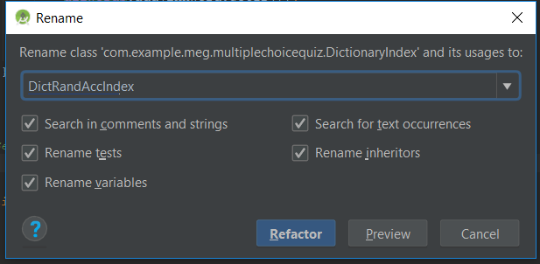

# Phase Three:

## Analysis:

As a result of timing I do not have the time to fix/ implement all of the issues found in previous phasing or implement the smaller features that would have brought a complete feel to the application because of this I will be providing the key elements and sections in pseudocode. Furthermore, as this is only code that has not and will not be implemented at this time my there will be no stakeholder input. However, all of these features will be implemented for a later release.

## Implementation (Pseudocode ONLY):

### Opening Files :

The below pseudocode would work for all files I would have to specify which file type when I was programming it, the reason I haven’t implemented this is timing as I would need to get this to work with a file tree / explorer which I don’t currently have time for

Public void main {

Try {

File pdfFile = new File (“ “)

if (desktop is supported) then

open file

else if

print (desktop not supported)

end if

else if

print (file does not exits)

end if

print (Done)

}

### File Directory:

Lists the files and the directory.

Class main {

Dir (File) = new file (“ “)

Arr child = list Dir

If (child is null) then

Print (directory does not exits or file not found)

Else if

For (I to length of child)

Print (filename)

End for

End if }

### Saving text files:

Class which throws FileNotFoundException

    {

        PrintStream out = new PrintStream(new File("A.txt"));

PrintStream console = System.out;

        System.setOut(out);

        print ("This will be written to the text file");

}

### TTS: Pitch:

Class setPitch(float pitch) {

if (pitch != this.pitch) then

this.pitch = pitch;

end if

if (isTTSInitialized) then

this.tts.[setPitch](https://www.codota.com/code/java/methods/android.speech.tts.TextToSpeech/setPitch)(pitch);

end if

if (state == State.PLAYING) then

executor.execute(speak);

end if

### Score sheets:

Class {

   File file = new File(filePath);

    try {

        FileWriter outputfile = new FileWriter(file);

        // create CSVWriter object filewriter object as parameter

        CSVWriter writer = new CSVWriter(outputfile);

        // adding header to csv

        String[] header = { "Name", "Class", "Marks" };

        writer.writeNext(header);

        // add data to csv

        String[] data1 = { "Aman", "10", "620" };

        writer.writeNext(data1);

        String[] data2 = { "Suraj", "10", "630" };

        writer.writeNext(data2);

        // closing writer connection

        writer.close(); }

Home page (ESL & Dyslexia):

public void onCreate(Bundle savedInstanceState) {

super.onCreate(savedInstanceState); setContentView(R.layout.main);

Button next = (Button) findViewById(R.id.Button01);

next.setOnClickListener(new View.OnClickListener() {

public void onClick(View view) {

Intent myIntent = new Intent(view.getContext(), Activity2.class);

startActivityForResult(myIntent, 0); } });

# Evaluation:

Overall, I am disappointed with the finish of this project, as a result of lack of time management I haven’t been able to finish as much of the phasing as I wanted. Currently, my project is still sections which is no use to a user however all of my stakeholders have agreed that the components on their own work fine and are suitable for their needs, which is a success. Therefore, should I have the chance to complete another programming project I would plan and be stricter with myself in order to get the different components to work. Furthermore, I found that making the move from java to Android studios was harder than I had anticipated so if I was to complete a project like this again I would make sure I was more familiar with the basic syntax before jumping straight into the programming, although I think that some of the issues I encountered was a result of my lack of programming knowledge and confidence in Java before starting. Consequently, so that I am ready should there be an opportunity to complete another project I will be working on my programming skills on a more regular basis. I am also disappointed that for some of the features they are still not refined for example the issues found throughout testing which I had planned to complete in phase three of this project, as a way of fixing this I would focus more on my timing. Additionally, I would choose a project that my phases can link slightly better as I feel that my phase one and two could be different project even though they are designed with the same group of stakeholders as the target audience.

However, while I am on the whole disappointed not everything failed, for example while the project is currently in separate sections for the most part they do work. Moreover, I have learnt what it takes to complete a software project from start to finish takes. This included coming up with a project idea, gathering stakeholders and then the more practical side of the programming and documenting the process. This is a success as it has shown me the work and effort required to get a small project completed, which has furthered my understanding of software development, which is important to me as I am hoping to work with in the computer science field. I am also pleased with certain aspects such as the quiz as it has complex coding concepts and data types that were new to me as a programmer thus I have been able to expand my programming knowledge which has allowed me to become more confident in my programming abilities. On the whole my success criteria for phase one and two were made however, both of these criteria’s where very limited and so are not the most reliable way of showing the progress and success this project has made. As a result, I feel that while having the sections working in some capacity I have overall failed to complete the success criteria as such I have decided to reflect upon what issues I either haven’t tackled due to lack of programming knowledge or timing below.

* The use of the extracting the files from the assets area to the APK wastes storage on the phone therefore, a future development for my app would be to extend the JWNI library to allow it to read the compressed dictionary directly from the assets area. I didn’t complete this at this stage as it requires quite a bit of coding which would have been too time consuming at this moment.
* There is a huge time delay between the quiz app opening and the first question appearing thus if I was to recomplete this project or finish this at a later date I would add a loading screen or another user interface screen, so the user is aware of what is happening.
* I would change some of phonetic groupings for the quiz as currently while the groups are phonetically correct some of the words been created are too far fetched making some of the questions too easy for the users which could lead them losing interest in the application.
* I would complete all of the smaller elements of this project such as the changing of pitch and speed of the TTS voice so that the users could tailor it more to their needs, furthermore, I would make sure that the home page for the quiz was completed so that the letter jumbling was more appropriate and specific to their needs.
* I would include new features such as the one I haven’t managed to implement as a result of lack of timing, but I would also include other aspects such as been able to play the quiz with others to make it more competitive.

Finally, while I believe that this project was a failure I do plan on completing it in my own time, furthermore, I have learnt many critical skills both related to the programming aspect that the inner working of a larger project and how to balance more than one research task at a time.

# Table One: Screenshots

|  |  |  |
| --- | --- | --- |
| Phase | Test number | Image |
| One | 1i | A screenshot of a cell phone  Description generated with very high confidence` |
| One | 1ii | A screenshot of a cell phone  Description generated with very high confidence |
| One | 1iii | A screenshot of a cell phone  Description generated with very high confidence |
| One | 1iv | A screenshot of a cell phone  Description generated with very high confidence |
| One | 1v | A screenshot of a cell phone  Description generated with very high confidence |
| Two | 1i + 1ii | A screenshot of a cell phone  Description generated with very high confidence |
| Two | 1vi | A screenshot of a cell phone  Description generated with very high confidenceA screenshot of a cell phone  Description generated with very high confidence |
| Two | 1viii | A screenshot of a cell phone  Description generated with very high confidenceA screenshot of a cell phone  Description generated with very high confidencesA screenshot of a cell phone  Description generated with very high confidence |

# Table Two: Videos;

|  |  |  |
| --- | --- | --- |
| Phase | Section it links to | Video |
| One | TTS |  |
| One | TTS |  |
| Two | Quiz |  |

1. [*"The Soundex Indexing System"*](https://www.archives.gov/research/census/soundex.html). [*National Archives and Records Administration*](https://en.wikipedia.org/wiki/National_Archives_and_Records_Administration). 2007-05-30*. Retrieved 2010-12-24*. – I used as a secondary source from Wikipedia.
2. Princeton University "About WordNet." [WordNet](https://wordnet.princeton.edu/). Princeton University. 2010. 